**Spatially differentiated yield and economic risks of rice planting date strategies for Indo-Gangetic Plains: A computational risk modelling approach**

# Abstract

Advancing the planting date of rice has been heralded as the entry point for system optimization in rice-wheat rotational cropping systems in the Indo-Gangetic Plains. Much of the evidence behind this recommendation focuses on the productivity and resilience benefits, but less on the monetary and risk implications of such a planting date adjustment. In this paper, we use a gridded crop simulation model and a computational risk model of evaluating risky portfolios to spatially assess the economic potential of alternative rice planting date strategies. We find that sowing a long duration variety of rice with monsoon onset is more economically beneficial even for a risk averse farmer consistent with prior evidence that showed that this strategy gives higher system caloric yield for a risk neutral farmer. Our approach has however identified locations in the area of interest for which a risk averse farmer would be indifferent or not adopt this strategy as compared to fixed date planting date recommendation with a long duration rice variety planting strategy.

# 1. Introduction

The Indo-Gangetic Plains (IGP) have been the food basket of India through a dominant rice-wheat cropping rotation system. Rice is grown in the monsoon season from May to October (also called kharif) while wheat is grown as an irrigated crop in winter season from November to April (also called rabi). Climate change and variability especially due to late monsoon onset which affects rice sowing and terminal heat stress which has significant yield penalty on wheat have posed significant pressures to the rice-wheat cropping system in the region. Recent compelling evidence (e.g., McDonald et al 2022, Urfels et al 2022, and Montes et al 2022) suggests that advancing the planting date of rice is one of the viable adaptation options.

Several studies have shown the importance of understanding spatial heterogeneity when recommending various inputs. McCullough et al (2022) and Harou et al (2017) for example, used data on experimental fertilizer application trials across sub-Saharan Africa (SSA) and Malawi respectively document the importance of spatial heterogeneity. Using exante regional gridded crop simulations, Urfels et al (2022) and Montes et al (2022) investigated the impact of different rice planting strategies on system level productivity, resilience, and environmental benefits. In this paper, we extend the exante analyses to consider impacts of rice planting strategies on crop level and system level productivity and economic risks. The key contribution is to provide a risk assessment framework that adds to the average comparisons of the crop model results. The risk assessment framework allows one to make assumptions about farmers risk preferences.

Recent studies (see, Hurley et al 2018, Suri 2011) have shown that heterogeneity in returns to technology adoption and the associated risk preferences of farmers may result in lack of adoption of profitable agricultural innovations. Most of these studies have focused on use of inorganic fertilizers and hybrid seed varieties. In the context of the EIGP, the adoption of fertilizers and hybrids seeds is already high. With stagnant yields, it is prudent to focus on yield improving agronomic practices.

This paper contributes to two strands of literature. The first strand of literature is on stability analyses of agricultural technology benefits based on ex ante cropping system assessments (e.g., Urfels et al 2022, Montes et al 2022). Montes et al (2022) use inter-annual standard deviation to analyze the stability of the planting date scenarios. Urfels et al (2022) used deviation from the mean caloric yield for each of the years when a shock occurred as a measure of yield instability. These measures of yield stability while a step better than mean comparisons fail to show whether the instability is high enough for a risk averse farmer to select the less risky option. In addition, these measures do not consider higher moments beyond mean and variability that may matter for distribution comparisons. In addition, we argue that stability analyses just as comparisons of means do not consider the trade-offs of achieving the highest returns with the lowest uncertainty.

These limitations are addressed in the second strand literature which focuses on the spatial risk assessment of economic benefits of agricultural innovations (e.g., Nalley and Barkley 2010, Hurley et al 2018). This literature attempts to optimize on the trade-offs of achieving the highest return and lowest uncertainty therefore allows one to choose strategies that are more robust. Using modern portfolio theory (Markowowitz 1959) which suggests that a strategy to maximize average returns may be a suboptimal strategy, Nalley and Barkley (2010) use a mean-variance analysis to optimally select wheat varieties that achieve highest return and lowest risk. This strategy still suffers from the limitation of using a subset of moments of the distribution. This is usually used by using stochastic dominance comparisons. Using long term weather data, crop simulation model results (APSIM), spatially explicit observed maize prices, and fertilizer prices, Hurley et al (2018) simulates whether weather risk affects the adoption of fertilizer and improved maize seeds. They use heterogeneity in soils and climate in a calibrated crop growth model to simulate the distributions of yields across adoption of fertilizer and improved maize seed scenarios. They also assessed the heterogeneity of farmer risk preferences.

We specifically follow the approach proposed by Hurley et al (2018) to estimate willingness to pay bounds for a risk averse farmer to likely adopt an alternative rice planting date strategy. We depart from their approach in two substantial ways. First, instead of fertilizers and improved varieties, we consider multiple management changes including sowing dates, irrigation amounts, and varieties differing on duration to maturity. Second, we consider a rice-wheat multi-crop system unlike Hurley et al (2018) who focus on maize only. Our application therefore considers more complex decisions.

We find that sowing a long duration variety of rice with monsoon onset has the highest system economic benefits consistent with prior evidence that showed that this strategy gives higher system caloric yields.

The rest of the paper is organized as follows. We present next the methods focusing on the computational risk assessments. In section 3 we present results and discussion of the yield and economic benefits of alternative planting date strategies. We finally conclude in section 4.

# 2. Methods

## 2.1. Data and scenarios

The data used in this paper is based on crop simulation model results reported in Urfels et al (2022) and Montes et al (2022). We use seven scenarios from crop simulation results reported in Urfels et al (2022). The scenarios correspond to variation ii irrigation, varietal duration and the planting of rice at the onset of the monsoon. Table 1 shows the details for the scenarios.

Table 1: Scenarios

|  |  |  |
| --- | --- | --- |
| Scenario number | Rice planting strategy | Description |
| S0 | Farmer practice | Farmers’ practice baseline without nutrient and water limitations to understand current limits |
| S1 | Fixed long (baseline) | Planting long duration variety at a fixed recommended date (state recommendation) |
| S2 | Fixed medium | Planting medium duration variety at a fixed recommended date |
| S3 | Onset long | Planting long duration rice variety at the onset of monsoon |
| S4 | Onset long supp | Supplementary irrigation for planting long duration varieties at monsoon onset |
| S5 | Onset medium |  |
| S6 | Onset medium supp | Supplementary irrigation for planting medium varieties at monsoon onset |

## 2.2. Computational spatial ex-ante economic model under risk aversion

#### 2.2.1. Yield risk

We compute spatially explicit willingness to pay bounds in rice and wheat yield equivalents for a risk averse farmer to definitely adopt or not adopt the interventions using second order stochastic dominance. Theoretically, second order stochastic dominance is related to the Arrow-Pratt measure risk aversion (Levy 2016). Meyer (1977) proved a theorem that cumulative distribution function $F(x)$ stochastically dominating $G(x)$ in the second order with respect to utility function $k(x)$ is equivalent to $F\left(x\right)$ being preferred or indifferent to $G(x)$ by all agents who are risk averse than an agent with utility function $k(x)$.

This implies that any risk averse farmer is likely to adopt if the yield advantage is such that the technology second order stochastically dominates another technology. We use a hypothetical experiment to demonstrate the approach (Figure 1). Based on mean comparisons, $G$ is clearly better than $F$ and $Q$. If we think in terms of distributional differences using first order stochastic dominance (Levy 2016), $G$ is clearly better than $Q$ because the cumulative distribution curve of $G$ is wholly to the right of $Q$. Consider next the case of $G$ and $F$ which have crossing cumulative distribution functions. For that comparison, second order stochastic dominance is needed to compare the area below and above the intersections. Visually, it can be deduced that $G$ second order stochastically dominates $F$. Consider the case of $F$ and $Q$, even though these have the same mean, one would want to choose which technology is better. It is difficult to visually assess the second order stochastic dominance ordering for these technologies. Using our approach, it is indeed unclear whether F stochastically dominates Q.

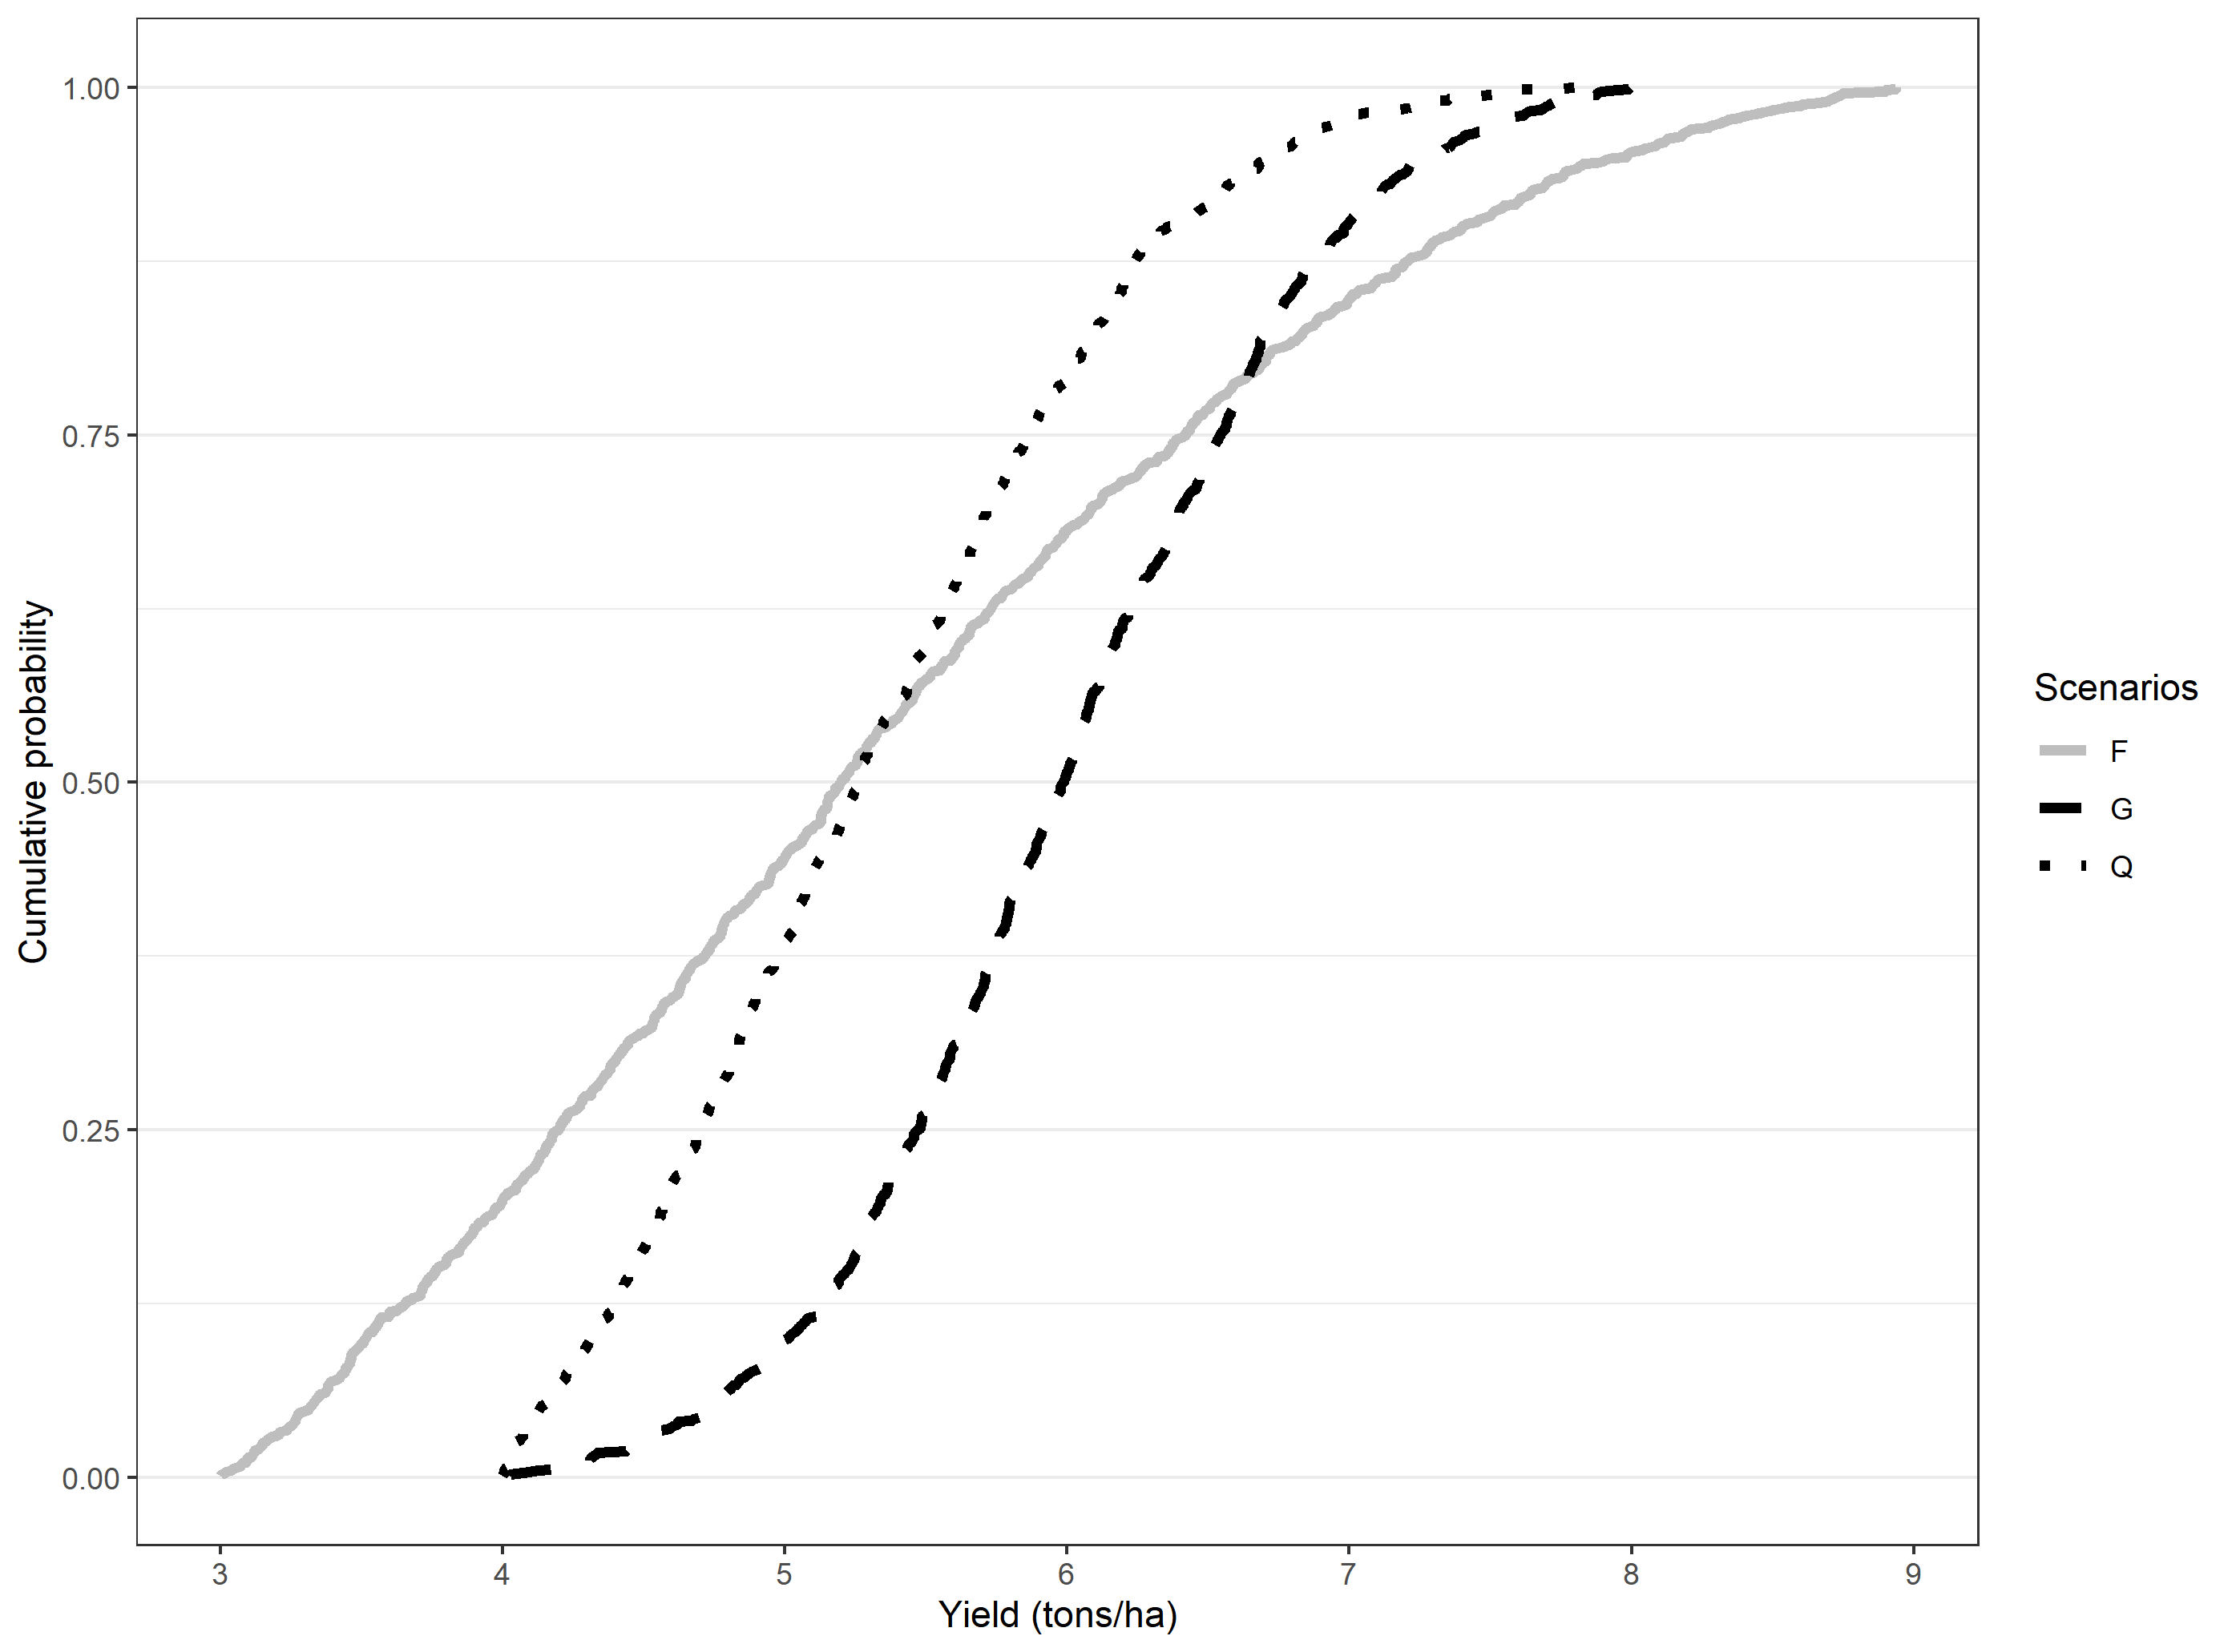

Figure 1: Hypothetical stochastic dominance assessment

***Note:*** We use a truncated normal distribution with four parameters: minimum (a), maximum (b), mean, and standard deviation (sd). The parameters used for each of the scenarios are as follows: G= rtruncnorm (n=1000,a=4,b=8, mean=6,sd=0.8), Q=rtruncnorm (n=1000,a=4,b=8, mean=5,sd=1), F=rtruncnorm (n=1000,a=3,b=9, mean=5,sd=2).

Beyond establishing second order stochastic dominance, it is important to understand how much yield advantage is needed for one technology to second order dominate another. For this, we use an approximation to compute the lower and upper bounds for one technology to second order stochastically dominate another.

According to Hurley et al (2018), the lower WTP bound that makes any risk-averse farmer prefer new technology (in this case scenarios other than the baseline) can be derived using second order stochastic dominance as follows:

$$WTP^{LB}=\max_{w}\left\{w:\int_{y^{L}}^{y}{F^{g}\left(z | ϵ\right)dz }≥\int_{y^{L}-w}^{y-w}{F^{r}\left(z | ϵ\right)dz }, ∀y≥\min\left\{y^{L}-w,y^{L}\right\} and ϵ \right\}$$

Where $WTP^{LB}$ is the lower bound for the willingness to pay (the maximum $w$ that when subtracted from the baseline yield distribution will still leave the farmer indifferent or prefer the new planting date strategy ), $y$ is the bounded random yield with $y^{L}≤y≤y^{U}$, $F^{g}$ is the cumulative distribution function for new planting strategy, $F^{r}$ is the cumulative distribution function for baseline planting strategy. Similarly, for the upper bound willingness to pay ($WTP^{UB}$),

$$WTP^{UB}=\min_{w}\left\{w:\int_{y^{L}-w}^{y-w}{F^{g}\left(z | ϵ\right)dz }≥\int_{y^{L}}^{y}{F^{r}\left(z | ϵ\right)dz }, ∀y≥\min\left\{y^{L}-w,y^{L}\right\} and ϵ \right\}$$

If both lower bound and upper bound are positive, then any risk averse farmer will prefer $g$ to $r$. Conversely, if both lower bound and upper bound are negative, then any risk averse farmer will prefer $r$ to $g$ (Hurley et al 2018). We use Octave for the computational analysis. Proceeding with the hypothetical distributions, we show in table 2 results from using our approach to compute upper and lower willingness to pay bounds. The WTP bounds are positive for the comparison between Q and G as well as F and G.

Table 2: Hypothetical distributions and willingness to pay bounds

|  |  |  |  |
| --- | --- | --- | --- |
| Panel (a): Truncated normal distribution parameters for the hypothetical distributions | | | |
| Truncated normal parameters | G | Q | F |
| N | 1000 | 1000 | 1000 |
| Min=a | 4 | 4 | 3 |
| Max=b | 8 | 8 | 9 |
| Mean | 6 | 5 | 5 |
| SD | 0.8 | 1 | 2 |
| Panel (b): Willingness to pay bounds from computational second order stochastic assessment | | | |
|  | Q(base)  vs G | Q vs F | F vs G |
| WTP lower bound (t/ha) | 0.036 | 0 | 0.499 |
| WTP upper bound (t/ha) | 0.763 | 0.218 | 1.384 |
| Interpretation | G F/SOSD Q | Not clear | G SOSD Q |

The sign for the WTP bounds gives the evaluation of the benefits of the technology for a risk averse farmer. If both upper and lower bounds are positive, the farmer is willing to pay for that strategy. The upper bound is the amount of money that would pay just to stay with the new technology, while the lower bound is the amount that would pay just to be indifferent between the new strategy and the base strategy. For negative WTP for upper and lower bound, it shows that they would need to be paid to accept the proposed strategy. Lower bound is the amount of money that they would accept to abandon their existing strategy. Upper bound is the amount of money that they would accept just to be indifferent between the new strategy and their existing strategy.

#### 2.2.2. Price ratio sensitivity

To test the robustness of the willingness to pay measures, we conduct a simple sensitivity analysis in which we vary the differential input price ratio of cost of the proposed rice planting strategy to the output prices. This is given by

$$kg of wheat (or rice) required to pay for planting date adjustment per ha(kg/ha)=\frac{Total cost of rice planting strategy adjustment per ha \left(\frac{Rs}{ha}\right) }{Price of wheat (or rice) per kg (\frac{Rs}{kg})}$$

#### 2.2.3. System economic benefits under risk

For cropping system assessment, we focus on the revenues derived from both rice and wheat. Willingness to pay is therefore in monetary terms rather that quantity terms. We use the same approach as stated above to determine if it is beneficial for a risk averse farmer to adopt the planting date strategy. When the revenue WTP is compared to cost of production differences between the baseline and the proposed strategy, we get the profit potential for the farmers in each pixel.

# 3. Results and discussion

## 3.1. Yield benefits over baseline for risk averse farmer

### Rice

Table 2 shows the descriptive statistics on the willingness to pay bounds (ton/ha) in rice yield equivalent for the planting date scenarios in comparison to the fixed date with long duration variety planting strategy. The WTP summary rows show the percentage of farmers who are more likely to benefit, be worse off or be indifferent between the planting date strategies. Almost 87% of the farmers would find the onset long as beneficial followed by onset long with supplemental irrigation (69%), fixed date with medium duration variety (57%), onset with medium duration variety (29%), onset with medium duration variety and supplemental irrigation (24%) and farmer practice (1%). For farmer practice, the average and median WTP bounds (both lower and upper) are negative implying that farmers will have to be paid almost 0.84 tons/ha to 3.21 to be indifferent or prefer it as compared to fixed date with long duration variety planting strategy.

Table 2: Rice WTP bounds with fixed long as baseline [with zero yield entries]

|  |  |  |  |  |  |  |  |
| --- | --- | --- | --- | --- | --- | --- | --- |
| Bound | Statistics | S0-S1 | S2-S1 | S3-S1 | S4-S1 | S5-S1 | S6-S1 |
| Upper bound | Mean | -0.84 | 2.92 | 3.95 | 3.57 | 1.91 | 1.80 |
| Standard deviation | 1.57 | 0.41 | 0.62 | 0.63 | 0.35 | 0.45 |
| Min | -2.20 | 2.27 | 2.89 | -1.75 | 1.29 | -1.95 |
| 10th percentile | -1.92 | 2.50 | 3.18 | 3.03 | 1.55 | 1.45 |
| 25th percentile | -1.87 | 2.61 | 3.44 | 3.20 | 1.64 | 1.60 |
| Median | -1.69 | 2.79 | 3.85 | 3.48 | 1.84 | 1.79 |
| 75th percentile | -0.41 | 3.18 | 4.40 | 3.95 | 2.13 | 2.03 |
| 90th percentile | 1.86 | 3.49 | 4.85 | 4.37 | 2.40 | 2.31 |
| Max | 4.88 | 4.19 | 5.73 | 5.33 | 3.12 | 2.97 |
| Lower bound | Mean | -3.21 | 0.44 | 1.43 | 0.73 | -0.61 | -0.86 |
| Standard deviation | 1.44 | 1.38 | 1.23 | 1.18 | 1.33 | 1.28 |
| Min | -6.59 | -1.73 | -1.71 | -3.91 | -2.66 | -3.04 |
| 10th percentile | -5.31 | -1.31 | -0.10 | -0.44 | -2.24 | -2.29 |
| 25th percentile | -4.28 | -0.66 | 0.43 | -0.12 | -1.68 | -1.91 |
| Median | -3.08 | 0.25 | 1.29 | 0.57 | -0.84 | -1.14 |
| 75th percentile | -2.06 | 1.37 | 2.27 | 1.47 | 0.28 | -0.08 |
| 90th percentile | -1.82 | 2.68 | 3.25 | 2.39 | 1.49 | 1.20 |
| Max | 0.76 | 3.69 | 4.79 | 4.37 | 2.45 | 2.35 |
| WTP summary | Clearly better (share) | 0.01 | 0.57 | 0.87 | 0.69 | 0.29 | 0.24 |
| Not clear (share) | 0.19 | 0.43 | 0.13 | 0.30 | 0.71 | 0.75 |
| Clearly worse (share) | 0.79 | 0.00 | 0.00 | 0.00 | 0.00 | 0.01 |
| Number of cells | 3386.00 | 3386.00 | 3386.00 | 3386.00 | 3386.00 | 3386.00 |

Figure 2 shows the spatial clustering of pixels for which the proposed planting strategy is clearly better, better or worse and clearly worse than the fixed calendar date state recommendation with long duration variety strategy. Among these, planting with monsoon onset with a long duration strategy seems to provide much advantage to much of the landscape. There is however parts of the landscape for which a farmer can follow either strategy.

In some pixels in the south-western part of Bihar, a risk averse farmer will benefit from following planting a medium duration variety with monsoon onset.

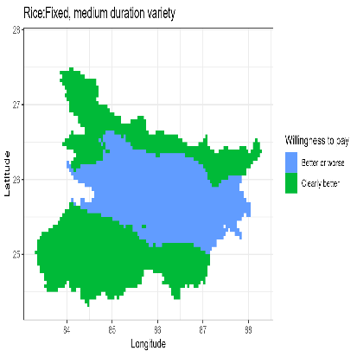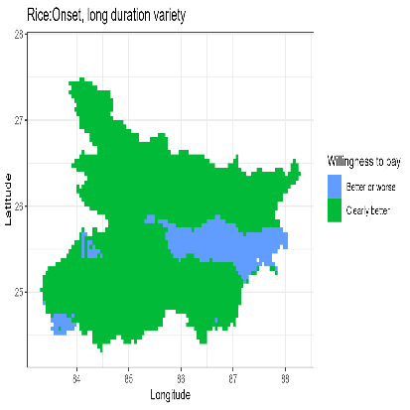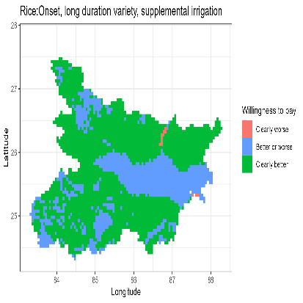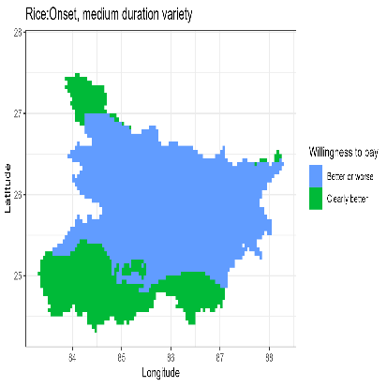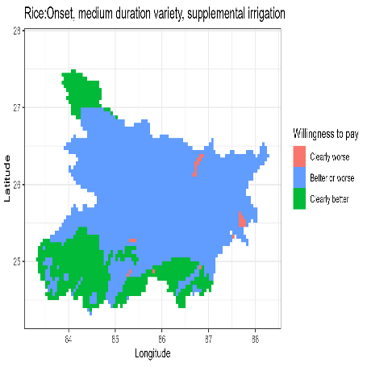

a

b

c

d

e

f

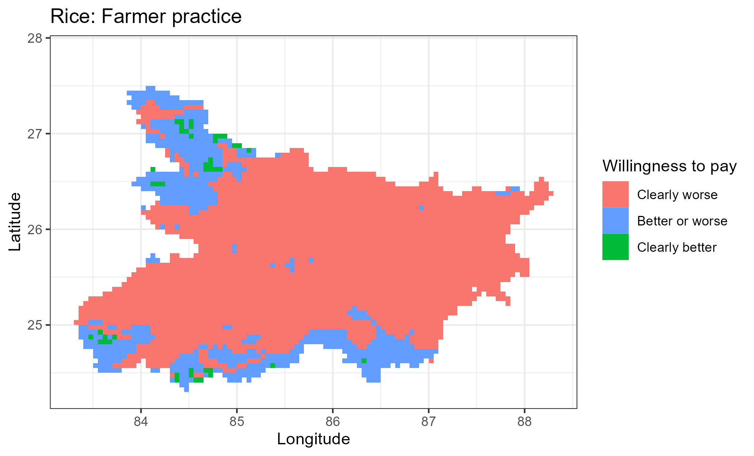

Figure 2: Willingness to pay **(rice yield t/ha)** for the strategy against a fixed long duration variety reference strategy using second order stochastic dominance

c

### Wheat

Table 3 shows descriptive statistics of the willingness to bounds in wheat yield equivalent (t/ha) for the scenarios in comparison to fixed date recommendation with long duration rice variety rice planting strategy (here after called fixed long strategy). Column (S0-S1) shows the comparison between farmer practice and fixed long strategy. It is apparent from the lower bound estimates, almost 90% of farmers have negative WTP lower bound for the farmer practice strategy when compared with the fixed long strategy. For about 25% of these, even the upper WTP is negative. Farmer practice is good strategy for risk averse farmers for only about 6% of the pixels. For wheat the best strategy seems to be fixed medium rice planting strategy in that all the pixels in Bihar will benefit with higher wheat yields as compared to the fixed long rice planting strategy.

Table 3: Wheat WTP bounds with fixed long as baseline

|  |  |  |  |  |  |  |  |
| --- | --- | --- | --- | --- | --- | --- | --- |
| Bound | Statistics | S0-S1 | S2-S1 | S3-S1 | S4-S1 | S5-S1 | S6-S1 |
| Upper bound | Mean | -0.34 | 1.28 | 1.23 | 0.64 | 0.20 | -0.37 |
| Standard deviation | 0.98 | 0.12 | 0.38 | 0.69 | 0.76 | 1.03 |
| Min | -2.60 | 0.60 | 0.18 | -2.39 | -1.11 | -2.39 |
| 10th percentile | -1.98 | 1.15 | 0.64 | -0.09 | -0.80 | -1.78 |
| 25th percentile | -1.16 | 1.23 | 0.98 | 0.48 | -0.37 | -1.22 |
| Median | 0.05 | 1.30 | 1.29 | 0.75 | 0.11 | -0.36 |
| 75th percentile | 0.32 | 1.37 | 1.50 | 1.04 | 0.82 | 0.47 |
| 90th percentile | 0.59 | 1.40 | 1.65 | 1.25 | 1.32 | 1.10 |
| Max | 1.59 | 1.53 | 2.05 | 1.91 | 1.69 | 1.61 |
| Lower bound | Mean | -1.71 | 1.03 | 0.66 | 0.04 | -0.24 | -1.15 |
| Standard deviation | 1.23 | 0.12 | 0.61 | 0.90 | 0.78 | 1.10 |
| Min | -3.72 | 0.38 | -0.89 | -3.47 | -1.42 | -3.72 |
| 10th percentile | -3.13 | 0.88 | -0.26 | -1.04 | -1.08 | -2.18 |
| 25th percentile | -2.64 | 0.98 | 0.23 | -0.34 | -0.87 | -1.88 |
| Median | -2.11 | 1.06 | 0.78 | 0.25 | -0.47 | -1.60 |
| 75th percentile | -0.01 | 1.11 | 1.17 | 0.64 | 0.36 | -0.49 |
| 90th percentile | 0.00 | 1.15 | 1.34 | 0.93 | 1.07 | 0.81 |
| Max | 1.34 | 1.24 | 1.62 | 1.49 | 1.35 | 1.23 |
| WTP summary | Clearly better (share) | 0.06 | 1.00 | 0.80 | 0.64 | 0.31 | 0.19 |
| Not clear | 0.52 | 0.00 | 0.20 | 0.25 | 0.25 | 0.19 |
| Clearly worse (share) | 0.42 | 0.00 | 0.00 | 0.11 | 0.44 | 0.62 |
| Number of cells | 3386.00 | 3386.00 | 3386.00 | 3386.00 | 3386.00 | 3386.00 |

Figure 3 shows the spatial distribution of willingness to pay classifications categorizing strategies on wheat yield whether they are worse, better or worse and better than the fixed long rice planting strategy. Fixed planting of a medium duration rice variety seems to be the best strategy to ensure higher wheat yields across all locations in Bihar.

Figure 3: Willingness to pay (wheat yield t/ha) for the strategy against a fixed long duration variety reference strategy using second order stochastic dominance.

a

b

c

d

e

f

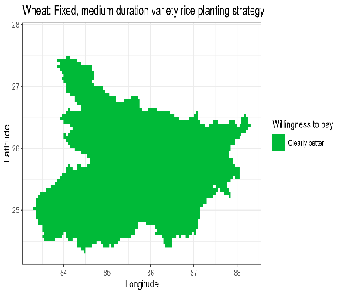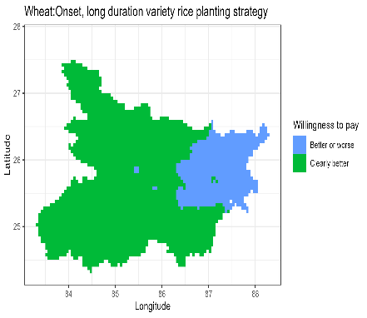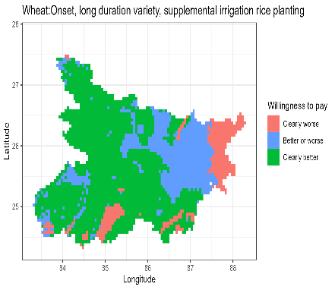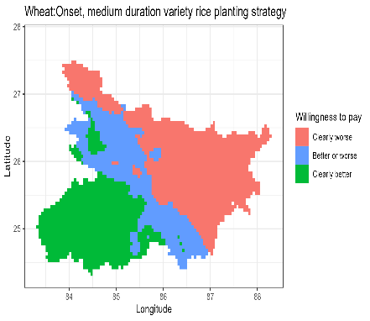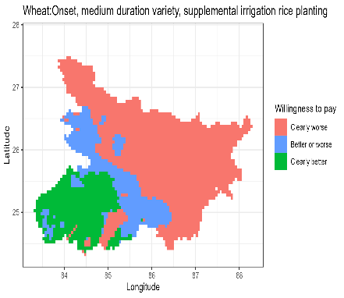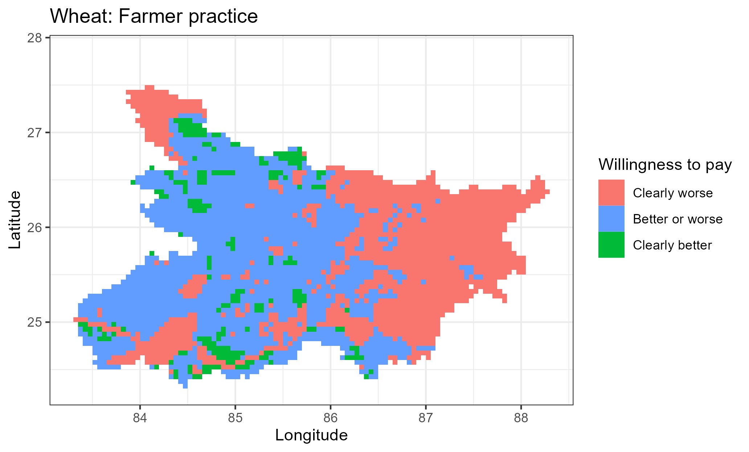

## 3.2. Price sensitivity and yield equivalent economic benefits for risk averse farmer

The analyses so far have focused on productivity gains to rice planting date adjustment. However, cost of production may also be affected by these adjustments. The changes in the cost of production may be due to direct changes in the inputs (e.g., alternative variety may be more expensive, sowing labor or hired machinery may be costly during the proposed sowing dates or irrigation may be costly). The changes may also be due to indirect changes in the production system. For example, sowing a long duration variety may require more irrigation which then increases irrigation costs. There are no studies that compute these costs comprehensively. We therefore test the robustness of the decisions on which strategy is beneficial to the farmers by using multiple of cost-output price ratios. Figure 4 shows the percentage distribution of risk averse farmers who would prefer that strategy as compared to the fixed long rice planting given increase input cost-output price ratio. At zero input cost changes, the percentage of farmers who prefer the corresponding strategies are as in table 2 and table 3. Panel (a) of Figure 4 shows that wheat is more responsive to changes in the costs of production as compared to rice. Overall, the ordering of the strategies remains intact with constant changes in costs of production except for implausibly high costs of production.

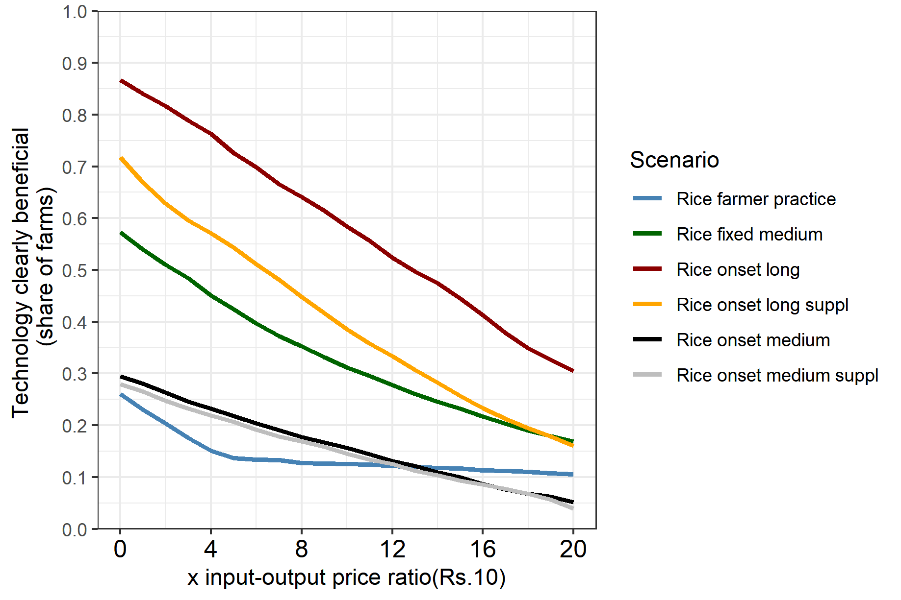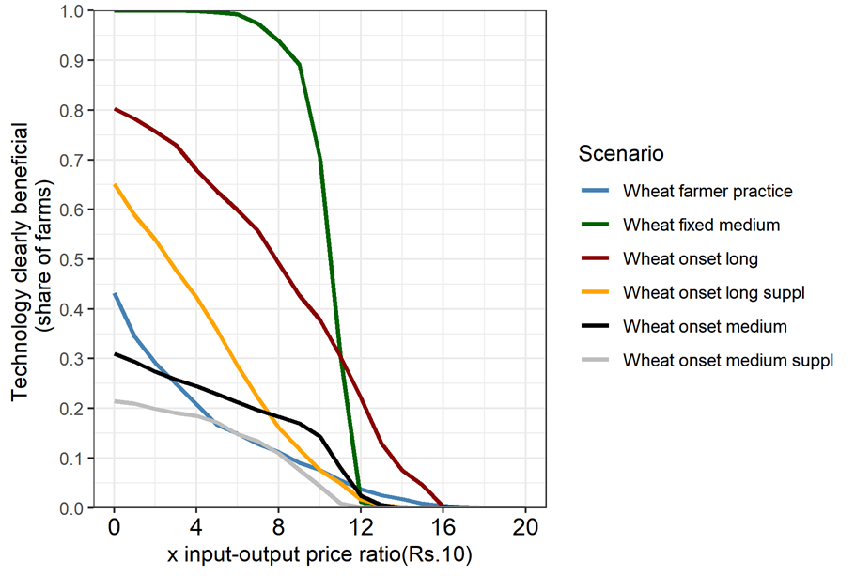

a. Without zero yield entries

Rice

Wheat

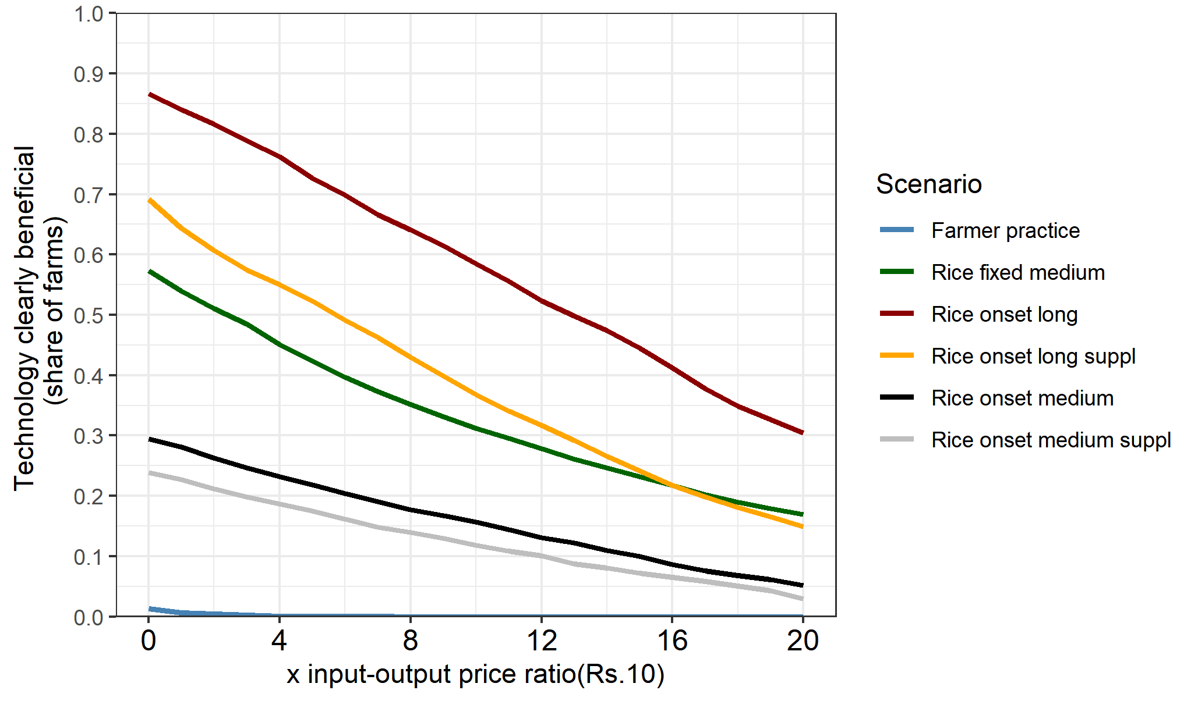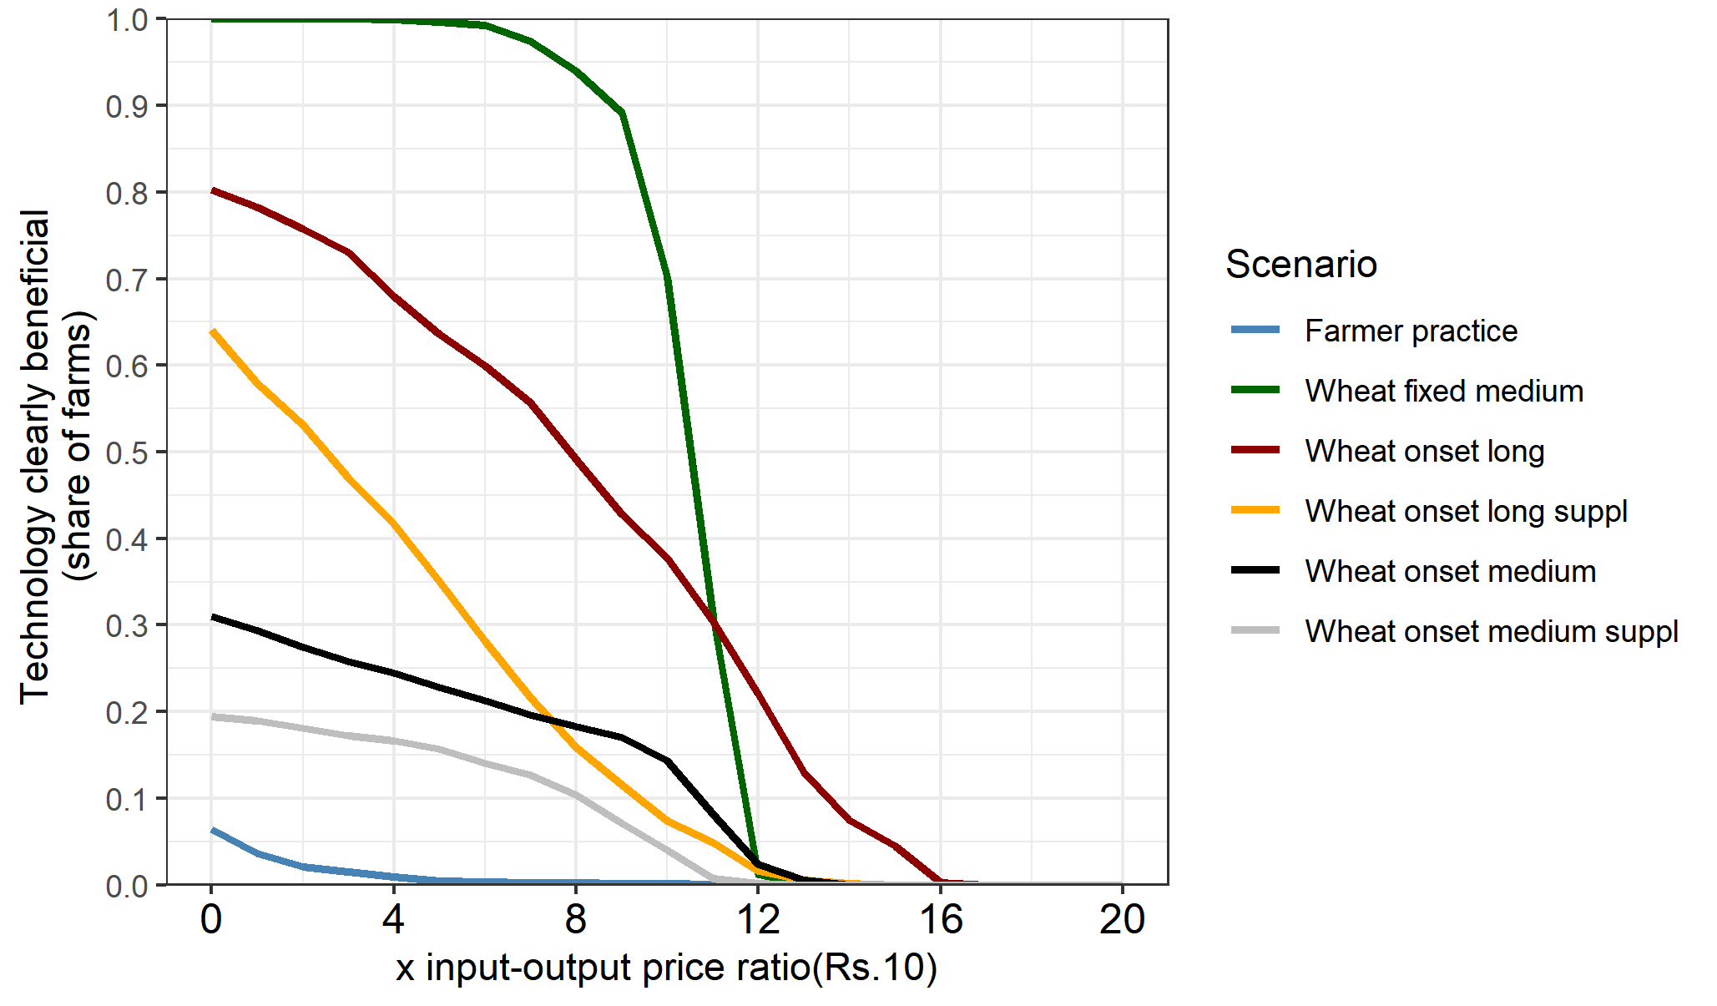

b. With zero yield entries

Rice

Wheat

Figure 4: Price sensitivity

## 3.3. System-wide economic benefits for a risk averse farmer

The approach involves using pixel level prices of rice and wheat to compute the revenues of following each of the scenarios. The pixel level prices are obtained by interpolating prices from the Landscape Diagnostic Survey (LDS) for 2017/18 season. We then use these economic indicators in the stochastic comparisons. Table 4 shows the descriptive statistics for the willingness to pay bounds. Starting with the percentage of pixels that would benefit from each of the scenarios as compared to the baseline, the statistics rows show that strategies are worse for farmers across most of the pixels are farmer practice (column 3) with 78% losing and onset medium with constrained irrigation (column 8) with 49% losing. These results are similar to those for rice.

Table 4: Gross revenue WTP (Rs. /ha) **bounds** with fixed long as baseline

|  |  |  |  |  |  |  |  |
| --- | --- | --- | --- | --- | --- | --- | --- |
| Bound | Statistics | S0-S1 | S2-S1 | S3-S1 | S4-S1 | S5-S1 | S6-S1 |
| 1 | 2 | 3 | 4 | 5 | 6 | 7 | 8 |
| Upper bound | Mean | -20013.05 | 55883.71 | 63616.27 | 49155.51 | 20429.77 | 7515.66 |
| Standard deviation | 32655.19 | 9074.47 | 17482.79 | 18110.54 | 18591.31 | 22571.44 |
| Min | -95787.35 | -10517.52 | -4369.18 | -19391.88 | -39021.17 | -50886.52 |
| 10th percentile | -59656.73 | 43928.94 | 38320.78 | 24205.65 | -867.53 | -16172.84 |
| 25th percentile | -51206.99 | 49765.59 | 49675.54 | 36655.93 | 4862.05 | -10466.29 |
| Median | -20973.23 | 56612.31 | 66844.77 | 52036.13 | 17028.43 | 228.33 |
| 75th percentile | -4138.39 | 62657.69 | 77845.09 | 63242.54 | 35833.15 | 26593.53 |
| 90th percentile | 24233.15 | 66609.76 | 85588.52 | 70133.90 | 49660.69 | 43570.32 |
| Max | 81513.61 | 77485.07 | 99480.34 | 88532.49 | 65034.09 | 61649.20 |
| Lower bound | Mean | -65401.51 | 22156.76 | 34908.06 | 19381.06 | -5512.13 | -15873.31 |
| Standard deviation | 30942.86 | 18377.46 | 19462.07 | 19031.29 | 24394.58 | 25250.42 |
| Min | -155222.24 | -30504.21 | -22649.54 | -49949.50 | -50621.89 | -67245.17 |
| 10th percentile | -106733.31 | 181.31 | 10065.78 | -2004.77 | -35187.29 | -46957.71 |
| 25th percentile | -89550.75 | 8369.37 | 20432.33 | 8001.31 | -24179.36 | -35355.27 |
| Median | -66430.47 | 19168.12 | 33537.89 | 18166.67 | -11178.09 | -19318.34 |
| 75th percentile | -44071.09 | 34650.94 | 48244.30 | 30751.22 | 13467.91 | 1582.32 |
| 90th percentile | -22426.40 | 50199.19 | 62462.09 | 45209.79 | 30279.24 | 19949.24 |
| Max | 77859.21 | 67605.46 | 84539.77 | 74983.11 | 55539.64 | 52194.78 |
| WTP summary | Clearly better (share) | 0.02 | 0.90 | 0.98 | 0.88 | 0.37 | 0.26 |
| Not clear (share) | 0.20 | 0.09 | 0.02 | 0.12 | 0.51 | 0.24 |
| Clearly worse (share) | 0.78 | 0.00 | 0.00 | 0.01 | 0.13 | 0.49 |
| Number of cells | 3429.00 | 3429.00 | 3429.00 | 3429.00 | 3429.00 | 3429.00 |

Spatially, there are pockets for which a risk averse farmer would not switch to the recommended fixed date with long duration variety strategy especially in the central pixels of Bihar.

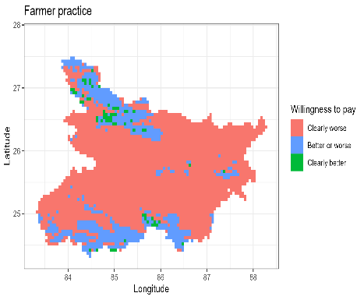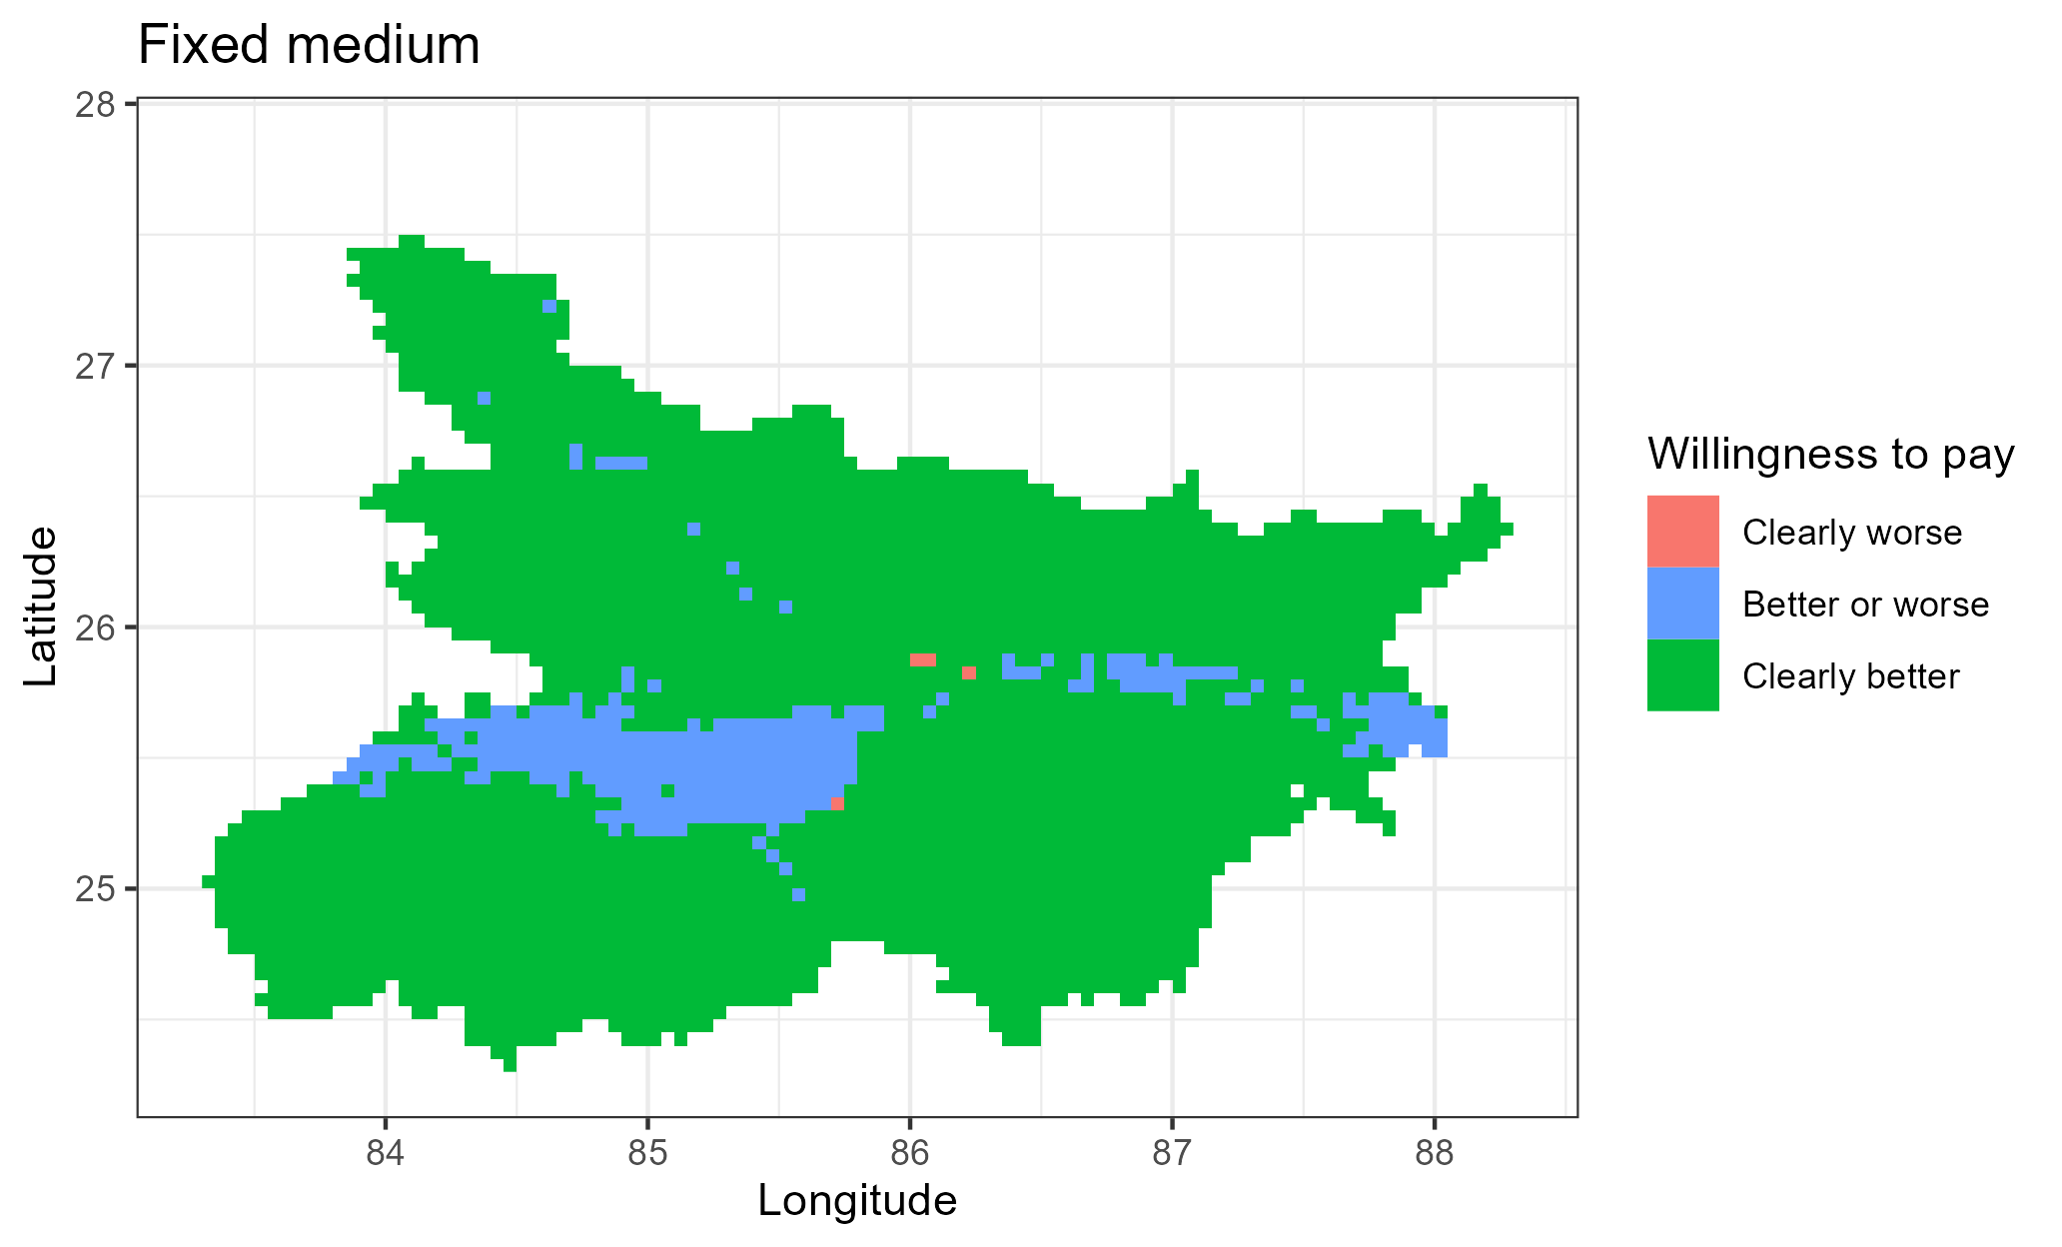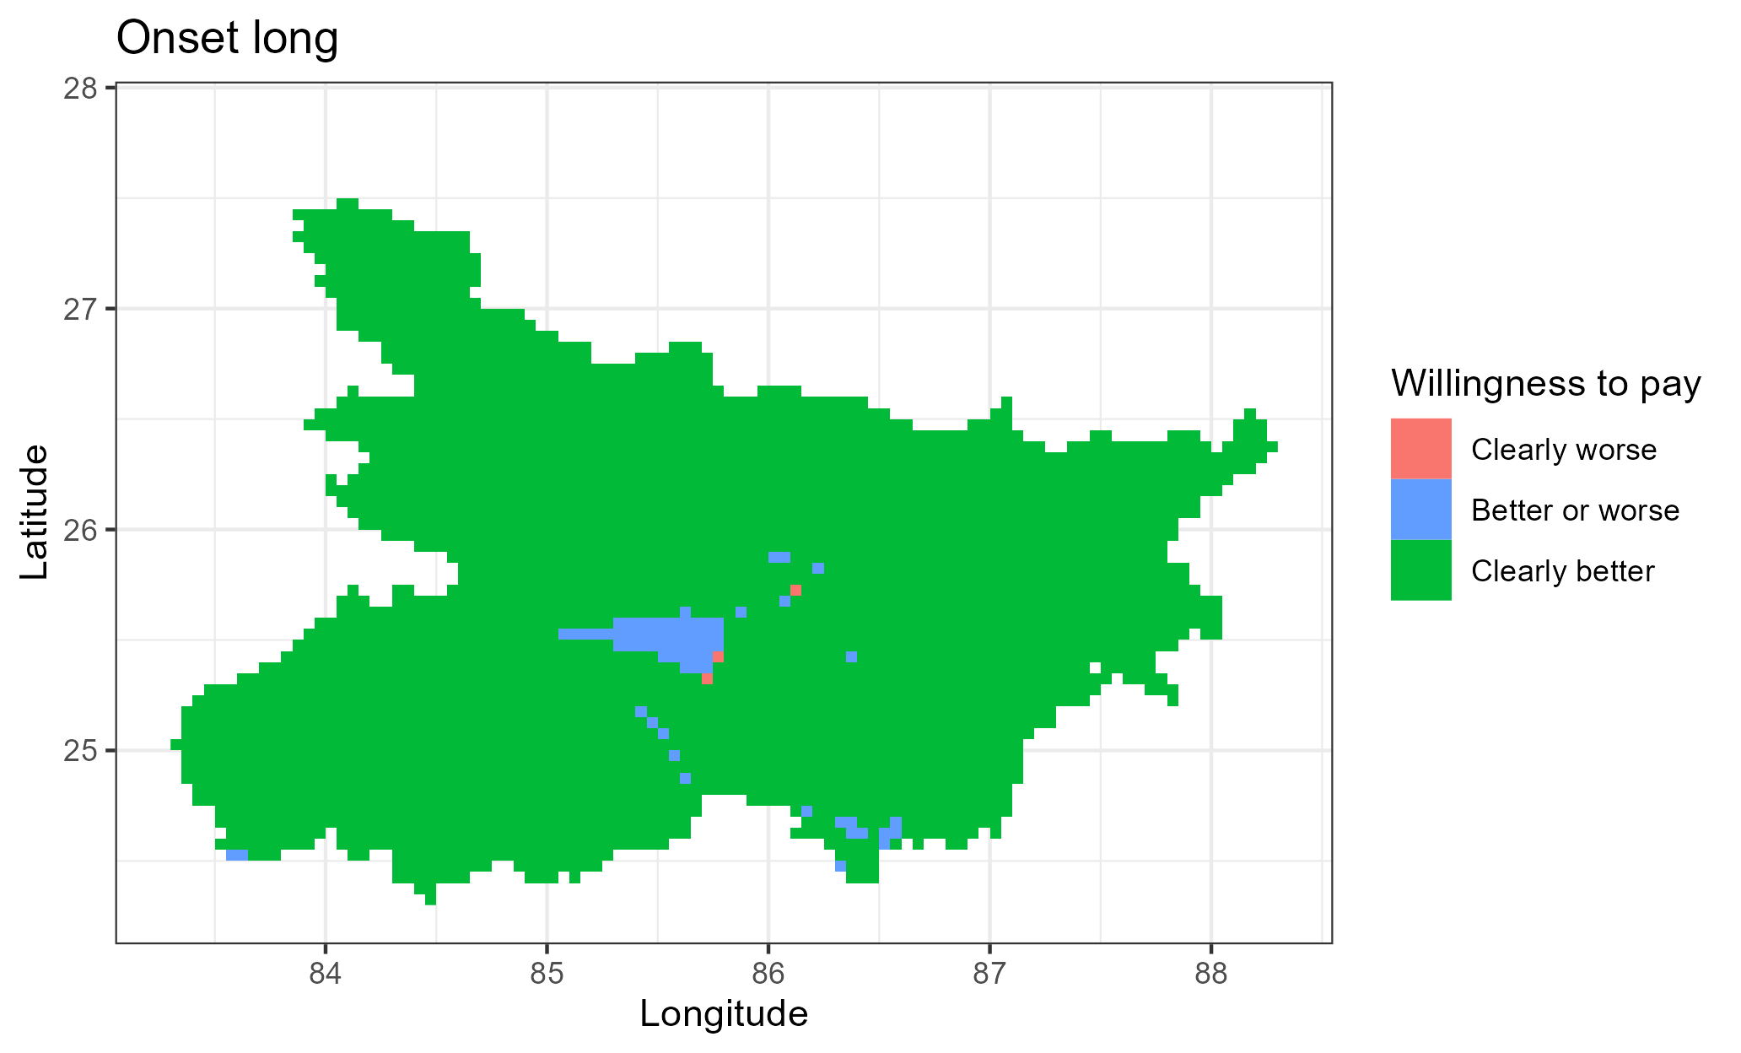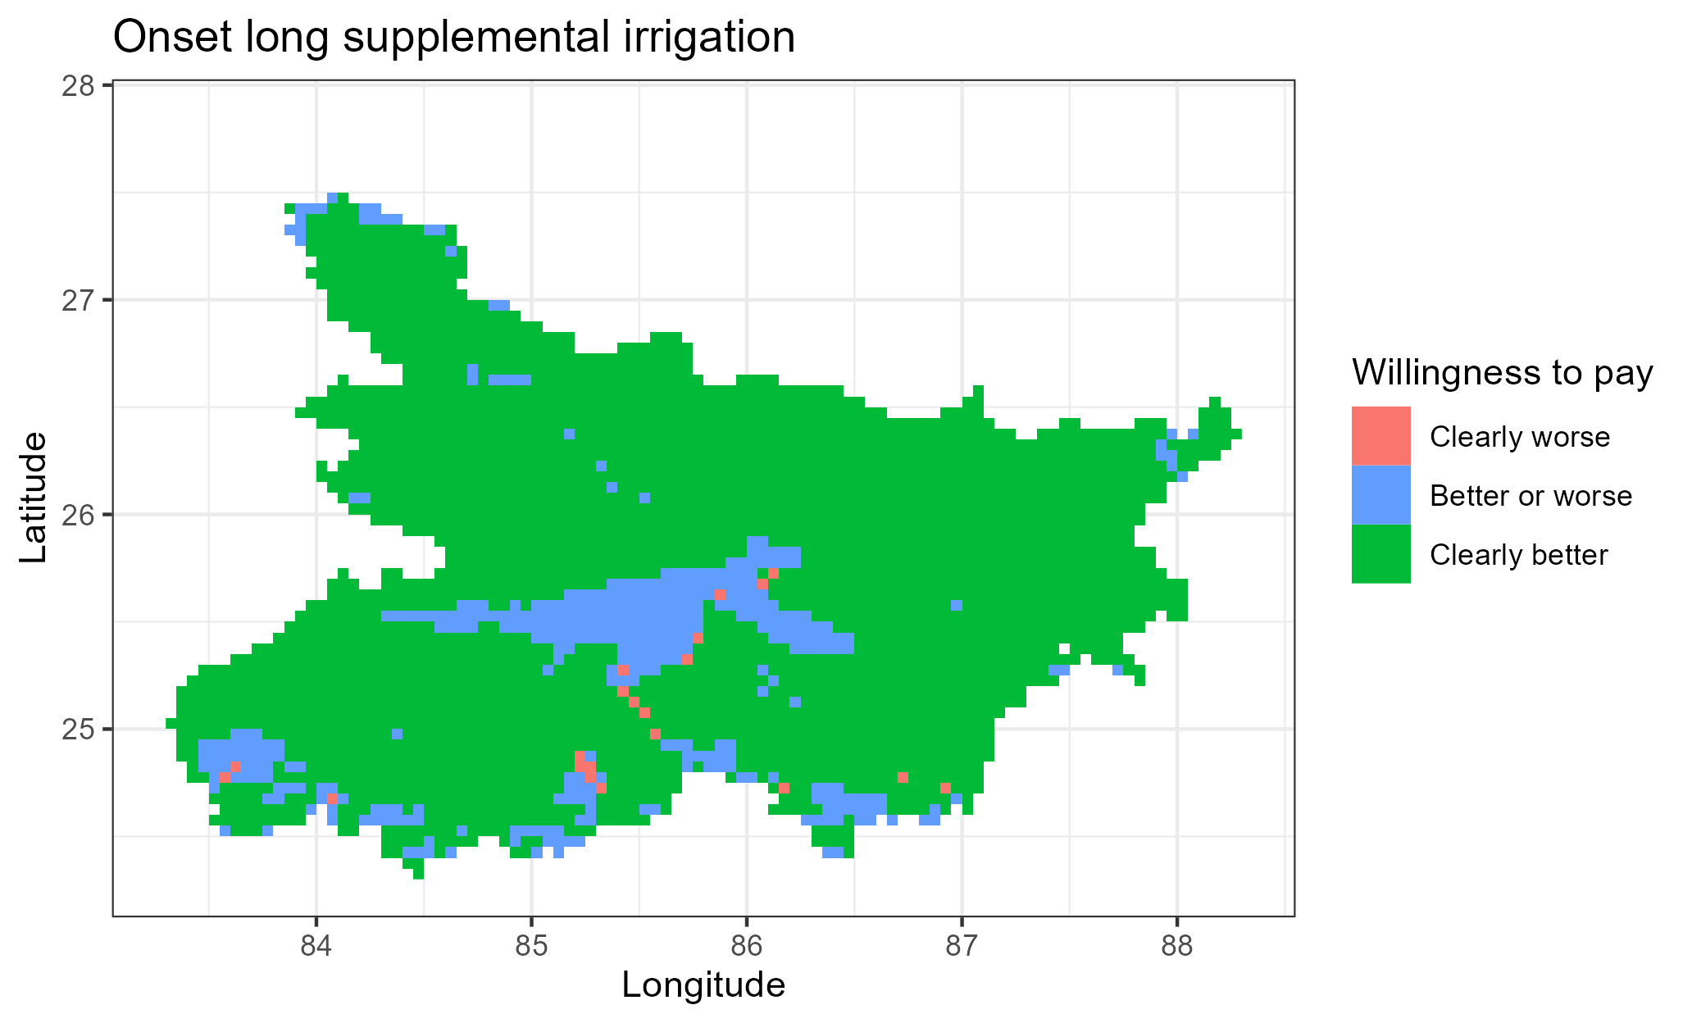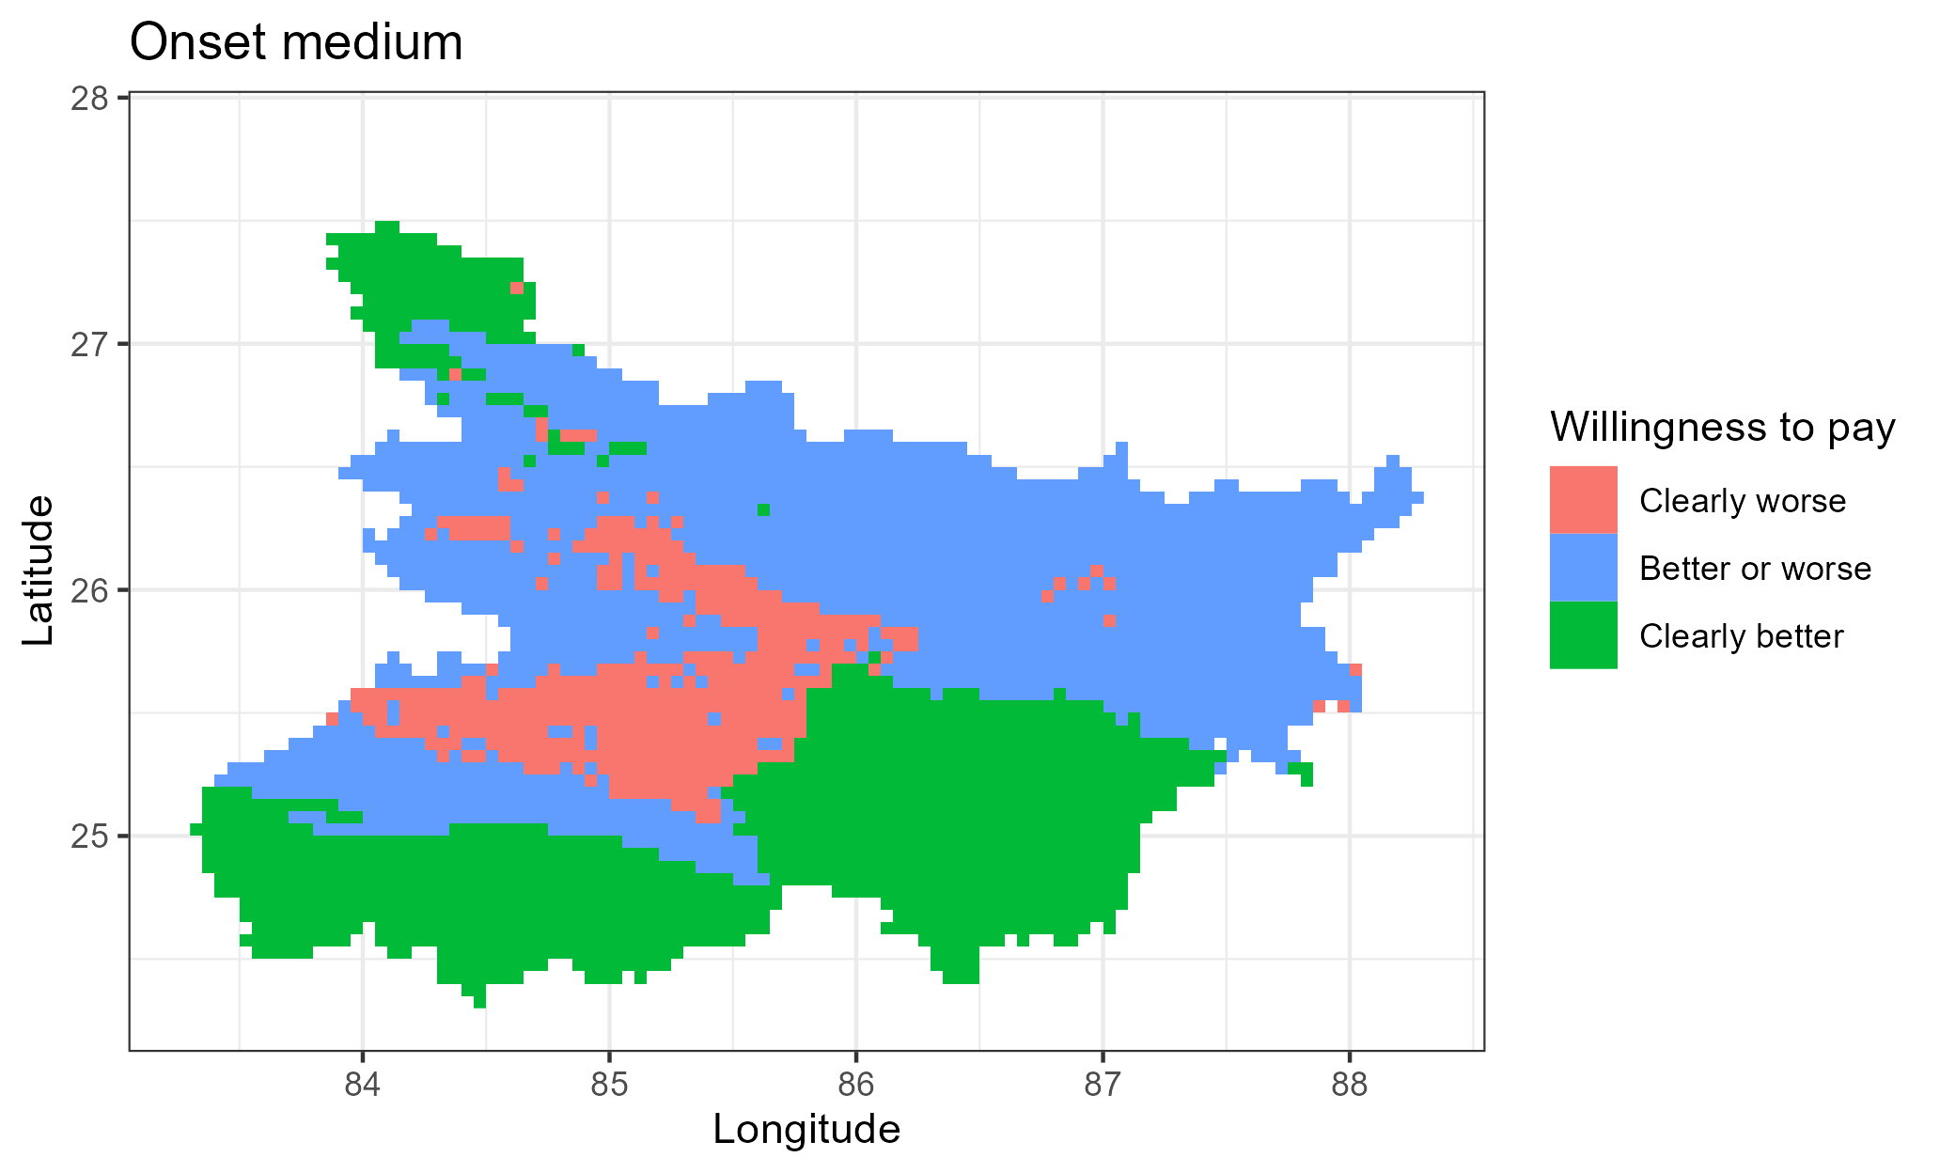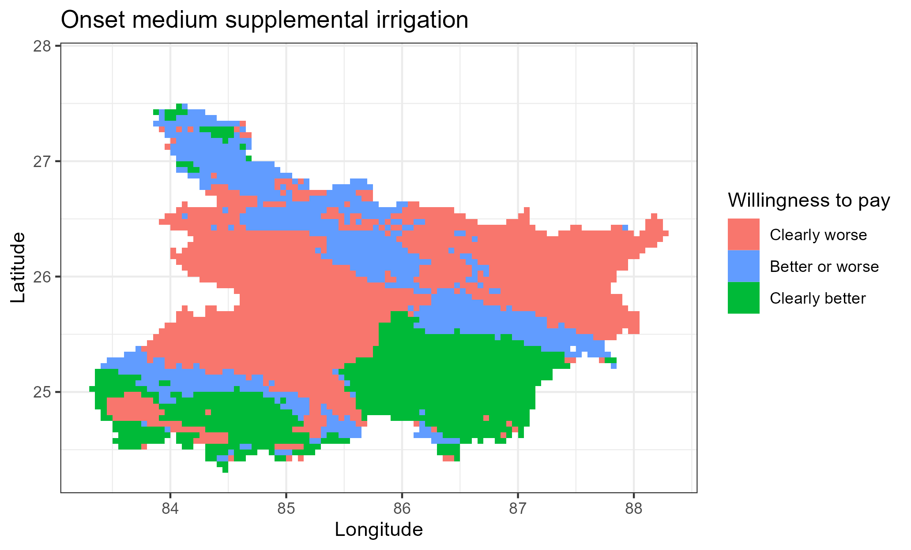

Figure 5: Spatial distribution of revenue WTP (where to target the scenarios)

## 3.4. Intra-Indo-Gangetic Plains Comparison

Focusing on the entire Indo-Gangetic Plains (IGP) and the revenue comparisons, we find that there is high variation on which scenarios would be beneficial for a risk-averse farmer.

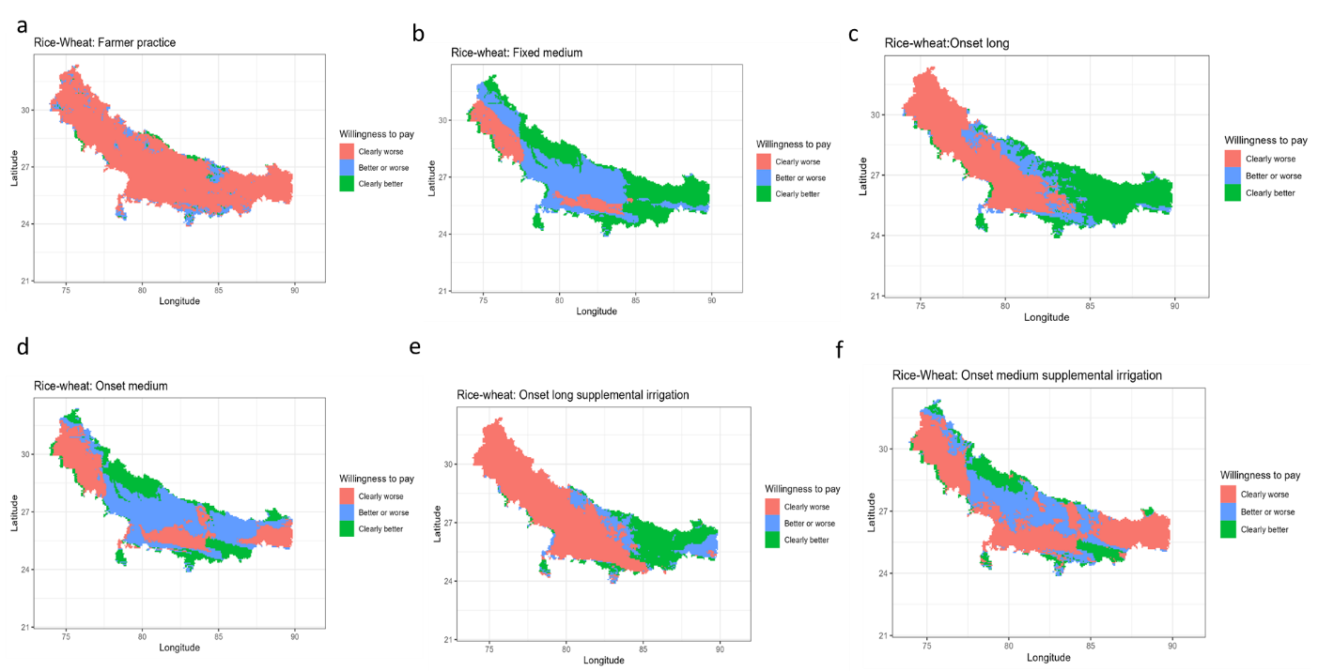

Figure 6: Spatial distribution of revenue WTP (where to target the scenarios)

# 4. Conclusion

Early sowing of rice has been proposed as the best strategy at optimizing productivity of rice-wheat rotation system in Bihar and the rest of the Indo-Gangetic Plains of India, Bangladesh, Nepal and Pakistan. Any cropping calendar adjustment is expected to be risky to the farmers and may be economically suboptimal. In this paper, we use an approach proposed by Hurley et al (2018) using computational second order stochastic dominance to calculate lower and upper bounds for which any risk averse farmer will be willing to pay to adopt an alternative rice planting date strategy.

We found that planting a long duration rice variety with monsoon onset is the most robust strategy.

# References

Harou, A., Liu, Y., Barrent, C.B., and You, L. 2017. “Variable returns to fertiliser use and the geography of poverty: Experimental and simulation evidence from Malawi.” *Journal of African Economies* 26 (3): 342-371. Doi: <https://doi.org/10.1093/jae/ejx002>.

Hurley, T., Koo, J., and Tesfaye, K. 2018. “Weather risk: how does it change the yield benefits of nitrogen fertilizer and improved maize varieties in sub-Saharan Africa?” *Agricultural Economics* 49: 711-723. Doi: 10.1111/agec.12454.

Ishtiaque, A., Singh, S., Lobell, D., Singh, B., Fishman, R., and Jain, M. 2022. “Prior crop season management constrains farmer adaptation to warming temperatures: Evidence from the Indo-Gangetic Plains.” *Science of the Total Environment* 807 (2). Doi: <https://doi.org/10.1016/j.scitotenv.2021.151671>.

Levy, H. 2016. “Stochastic Dominance: Investment Decision Making under Uncertainty.” Third Edition. Springer.

McCullough, E.B., Quinn, J.D., Simons, A.M. 2020. “Profitability of climate-smart soil fertility investment varies widely across sub-Saharan Africa.” *Nature Food* 3:275-285. Doi: <https://doi.org/10.1038/s43016-022-00493-z>.

Meyer, J.1977. “Second degree stochastic dominance with respect to a function.” *International Economic Review* 18(2): 477-487. Doi: <https://doi.org/10.2307/2525760>.

Montes, C., Urfels, A., Han, E., and Balwinder-Singh. 2022. “Planting rice at monsoon onset could mitigate the impact of temperature stress on rice-wheat systems of Bihar, India.” *Atmosphere* 14(1), 40. Doi:  <https://doi.org/10.3390/atmos14010040>.

McDonald, A.J., Balwinder-Singh., Keil, A., Srivastava, A., Craufurd, P., Kishore, A., Kumar, V., Paudel, G., Singh, S., Singh, A.K., Sohane, R.K., and Malik, R.K. 2022. “Time management governs climate resilience and productivity in the coupled rice-wheat cropping systems of eastern India.” Nature Food. Doi: <https://doi.org/10.1038/s43016-022-00549-0>.

Nalley, L.L., and Barkley, A.P. 2010. “Using Portfolio Theory to Enhance Wheat Yield Stability in Low-Income Nations: An Application in the Yaqui Valley of Northwestern Mexico.” *Journal of Agricultural and Resource Economics* 35(2): 334-347. Url: <https://www.jstor.org/stable/41960521>.

Newport, D., Lobell, D.B., Singh, B., Srivastiva, A., Rao, P., Umashaanker, M., Malik, R.K., McDonald, A., and Jain, M. 2020. “Factors Constraining Timely Sowing of Wheat as an Adaptation to Climate Change in Eastern India.” *Weather, Climate and Society* 515-528. Doi: <https://doi.org/10.1175/WCAS-D-19-0122.1>.

Suri, T. 2011. “Selection and Comparative Advantage in Technology Adoption.” *Econometrica* 79(1): 159-209. Doi:10.3982/ECTA7749.

Urfels, A., McDonald, A.J., Halsema, G., Struik, P.C., Kumar, P., Malik, R.K., Poonia, S.P., Singh, B., Singh, D.K., Singh, M., Krupnik, T.J. 2021. “Socio-ecological analysis of timely rice planting in Eastern India.” *Agronomy for Sustainable Development* 41: 14. Doi: <https://doi.org/10.1007/s13593-021-00668-1>.

Urfels, A., Montes, C., Balwinder-Singh, Halsema, G., Struik, P., Krupnik, T., and McDonald, J. 2022. “Climate adaptative rice planting strategies diverge across environmental gradients in the Indo-Gangetic Plains.” *Environmental Research Letters* 17: 124030. Doi: 10.1088/1748-9326/aca5a2.

# Appendices

**Appendix: Theorem relating second order stochastic dominance to risk aversion**

**Theorem [Meyer (1977, theorem 2)]:** For cumulative distribution functions $F(x)$ and $G(x)$, $\int_{0}^{y}{\left[G\left(x\right)-F\left(x\right)\right]dk\left(x\right)≥0, ∀y∈[0,1]}$

If and only if

$$\int_{0}^{1}{u\left(x\right)dF\left(x\right)≥\int_{0}^{1}{u\left(x\right)dG(x)}}, ∀u\left(x\right)∈U\left(\frac{k''(x)}{k(x)},∞\right)$$

## Appendix A: Computing WTP bounds and benefits for risk averse farmer

We follow closely the notation and derivation by Hurley et al (2018). Consider the following notation

$y$: Bounded random yield where $y^{L}≤y≤y^{U}$,

$f^{r}(y)$: Yield density functions for baseline farmer practice

$f^{g}(y)$: Yield density functions for new agronomic innovation

$F^{r}(y)$: Cumulative distribution functions for baseline farmer practice

$F^{g}$: Cumulative distribution functions for new agronomic innovation

A farmer has a thrice differentiable, risk averse utility of yield function such that $U^{'}\left(y\right)>0$, and $U^{''}\left(y\right)<0$

A farmer is expected to weakly prefer the new agronomic management innovation if

$$\int_{y^{L}}^{y^{U}}{U\left(y\right)f^{g}\left(y\right)dy≥}\int_{y^{L}}^{y^{U}}{U\left(y\right)}f^{r}\left(y\right)dy$$

One may compare the area under the cumulative distributions

If

$\int_{y^{L}}^{y^{U}}{F^{g}\left(z\right)dz≥}\int_{y^{L}}^{y^{U}}{F^{r}\left(z\right)dz},$ $∀y$

Then the new agricultural innovation will be weakly preferred.

With price risks and production costs,

$$\int_{ϵ}{\int_{p>0}{\int_{y^{L}}^{y^{U}}{U\left(py-c^{g}\right)A)f^{g}\left(y | ϵ\right)dy h\left(p | ϵ\right)dpϕ(ϵ)}}}≥\int_{ϵ}{\int_{p>0}{\int_{y^{L}}^{y^{U}}{U\left(py-c^{r}\right)A)f^{r}\left(y | ϵ\right)dy h\left(p | ϵ\right)dpϕ(ϵ)}}}$$

**WTP question is:** How much wheat/rice per hectare would a risk-averse farmer be willing to give up/pay to use the new agronomic innovation?

**Answer:** It is the $w$ that satisfies,

$$\int_{ϵ}{\int_{p>0}{\int_{y^{L}}^{y^{U}}{U\left(p\left(y-w\right)-c^{g}\right)A)f^{g}\left(y | ϵ\right)dy h\left(p | ϵ\right)dpϕ(ϵ)}}}=\int_{ϵ}{\int_{p>0}{\int_{y^{L}}^{y^{U}}{U\left(py-c^{r}\right)A)f^{r}\left(y | ϵ\right)dy h\left(p | ϵ\right)dpϕ(ϵ)}}}$$

According to Hurley et al (2018), the lower WTP bound that makes any risk-averse farmer prefer new technology (in this case scenarios other than the baseline) can be derived using second order stochastic dominance as follows:

$$WTP^{LB}=\max_{w}\left\{w:\int_{y^{L}}^{y}{F^{g}\left(z | ϵ\right)dz }≥\int_{y^{L}-w}^{y-w}{F^{r}\left(z | ϵ\right)dz }, ∀y≥\min\left\{y^{L}-w,y^{L}\right\} and ϵ \right\}$$

Where $WTP^{LB}$ is the lower bound for the willingness to pay.

Similarly, for the upper bound,

$$WTP^{UB}=\min_{w}\left\{w:\int_{y^{L}-w}^{y-w}{F^{g}\left(z | ϵ\right)dz }≥\int_{y^{L}}^{y}{F^{r}\left(z | ϵ\right)dz }, ∀y≥\min\left\{y^{L}-w,y^{L}\right\} and ϵ \right\}$$

**If *both lower bound and upper bound are positive***, then any risk averse farmer will prefer $g$ to $r$. Conversely, if *both lower bound and upper bound are negative*, then any risk averse farmer will prefer $r$ to $g$.

To include price information, we simply compare the WTP bounds to the price information

Table A1: Interpretation of willingness to pay bounds

|  |  |  |  |
| --- | --- | --- | --- |
| Lower bound | Upper bound | General interpretation | Specific intepretation |
| Negative | Negative | Need to be paid to take up new strategy | * Need to be paid **upper bound amount** to be indifferent * Need to be paid lower bound amount to **abandon base strategy** |
| Negative | Positive | Indifferent | * Need to be paid lower bound amount to **abandon base strategy** * Willing to pay upper bound amount to stay with new strategy |
| Positive | Positive | Willing to pay for the new strategy | * Willing to pay lower bound **amount to be indifferent** * Willing to pay upper bound amount to stay with new strategy |

## Appendix B: Farmer practice as the baseline with zero yield entries

Table B1: Willingness to pay bound **(rice ton/ha)** descriptive **statistics [Farmer practice as baseline]**

|  |  |  |  |  |  |  |  |
| --- | --- | --- | --- | --- | --- | --- | --- |
| Bound | Statistics | S1-S0 | S2-S0 | S3-S0 | S4-S0 | S5-S0 | S6-S0 |
| Upper bound | Weighted Mean_UB | 3.21 | 4.91 | 5.86 | 5.38 | 3.87 | 3.73 |
| Weighted SD_UB | 1.44 | 0.65 | 0.93 | 1.15 | 0.62 | 0.78 |
| Min_UB | -0.76 | 2.39 | 0.34 | -0.56 | 1.38 | -2.55 |
| Percentile10_UB | 1.82 | 4.43 | 4.92 | 3.87 | 3.40 | 2.57 |
| Percentile25_UB | 2.06 | 4.66 | 5.52 | 5.14 | 3.70 | 3.65 |
| Median_UB | 3.07 | 4.98 | 5.89 | 5.57 | 3.95 | 3.87 |
| Percentile75_UB | 4.28 | 5.27 | 6.38 | 6.05 | 4.19 | 4.12 |
| Percentile90_UB | 5.31 | 5.53 | 6.74 | 6.47 | 4.40 | 4.34 |
| Max_UB | 6.59 | 6.62 | 8.28 | 7.82 | 5.40 | 5.30 |
| Lower bound | WeightedMean_LB | 0.84 | 2.13 | 3.19 | 2.59 | 1.08 | 0.90 |
| WeightedSD_LB | 1.57 | 1.78 | 1.57 | 1.60 | 1.80 | 1.81 |
| Min_LB | -4.88 | -1.15 | -0.99 | -4.89 | -2.49 | -5.45 |
| Percentile10_LB | -1.87 | -0.11 | 1.28 | 0.73 | -1.18 | -1.27 |
| Percentile25_LB | 0.41 | 0.53 | 1.87 | 1.47 | -0.51 | -0.61 |
| Median_LB | 1.69 | 1.90 | 2.90 | 2.24 | 0.81 | 0.45 |
| Percentile75_LB | 1.87 | 4.03 | 4.82 | 3.95 | 2.97 | 2.80 |
| Percentile90_LB | 1.92 | 4.56 | 5.34 | 4.94 | 3.53 | 3.46 |
| Max_LB | 2.20 | 5.48 | 6.65 | 6.13 | 4.26 | 4.18 |
|  | Clearly better (share) | 0.79 | 0.87 | 1.00 | 0.95 | 0.64 | 0.57 |
| Not clear | 0.19 | 0.13 | 0.00 | 0.05 | 0.36 | 0.43 |
| Clearly worse (share) | 0.01 | 0.00 | 0.00 | 0.00 | 0.00 | 0.00 |
| Total hectares | 3386.00 | 3386.00 | 3386.00 | 3386.00 | 3386.00 | 3386.00 |
| Number of cells | 3386.00 | 3386.00 | 3386.00 | 3386.00 | 3386.00 | 3386.00 |

Note:

Table B2: Willingness to pay bound **(wheat ton/ha)** descriptive statistics **[Farmer practice as baseline]**

|  |  |  |  |  |  |  |  |
| --- | --- | --- | --- | --- | --- | --- | --- |
| Bound | Statistics | S1-S0 | S2-S0 | S3-S0 | S4-S0 | S5-S0 | S6-S0 |
| Upper bound | Weighted Mean_UB | 1.71 | 2.90 | 2.79 | 2.17 | 1.70 | 3.59 |
| Weighted SD_UB | 1.23 | 1.18 | 1.13 | 1.27 | 1.21 | 51.45 |
| Min_UB | -1.34 | -0.02 | -0.25 | -3.32 | -0.71 | -3.32 |
| Percentile10_UB | 0.00 | 1.20 | 1.24 | 0.54 | -0.09 | -0.48 |
| Percentile25_UB | 0.01 | 1.37 | 1.51 | 1.00 | 1.11 | 0.21 |
| Median_UB | 2.11 | 3.31 | 3.04 | 2.38 | 1.62 | 0.76 |
| Percentile75_UB | 2.64 | 3.77 | 3.61 | 3.15 | 2.45 | 1.45 |
| Percentile90_UB | 3.13 | 4.21 | 4.24 | 3.76 | 3.27 | 2.71 |
| Max_UB | 3.72 | 4.70 | 4.84 | 4.64 | 4.78 | 1000.00 |
| Lower bound | WeightedMean_LB | 0.34 | 1.46 | 1.25 | 0.65 | 0.39 | 2.26 |
| WeightedSD_LB | 0.98 | 0.94 | 0.74 | 1.07 | 0.94 | 51.52 |
| Min_LB | -1.59 | -0.42 | -1.03 | -4.67 | -1.29 | -4.63 |
| Percentile10_LB | -0.59 | 0.55 | 0.51 | -0.15 | -0.60 | -1.79 |
| Percentile25_LB | -0.33 | 0.84 | 0.79 | 0.28 | -0.32 | -1.16 |
| Median_LB | -0.05 | 1.12 | 1.09 | 0.65 | 0.24 | -0.41 |
| Percentile75_LB | 1.16 | 2.16 | 1.54 | 1.07 | 0.91 | 0.21 |
| Percentile90_LB | 1.98 | 3.02 | 2.36 | 1.98 | 1.27 | 0.86 |
| Max_LB | 2.60 | 3.74 | 4.03 | 3.77 | 3.61 | 1000.00 |
|  | Clearly better (share) | 0.42 | 0.99 | 0.99 | 0.86 | 0.59 | 0.38 |
| Not clear | 0.52 | 0.01 | 0.01 | 0.13 | 0.29 | 0.46 |
| Clearly worse (share) | 0.06 | 0.00 | 0.00 | 0.01 | 0.11 | 0.17 |
| Total hectares | 3386.00 | 3386.00 | 3386.00 | 3386.00 | 3386.00 | 3386.00 |
| Number of cells | 3386.00 | 3386.00 | 3386.00 | 3386.00 | 3386.00 | 3386.00 |

Note:

## Appendix C: Fixed long as baseline without zero yield entries

Table C1: **Rice WTP bounds (t/ha)** with fixed long as baseline [without zero yield entries]

|  |  |  |  |  |  |  |  |
| --- | --- | --- | --- | --- | --- | --- | --- |
| Bound | Statistics | S0-S1 | S2-S1 | S3-S1 | S4-S1 | S5-S1 | S6-S1 |
| Upper bound | Weighted Mean_UB | 0.93 | 2.92 | 3.95 | 3.63 | 1.91 | 1.88 |
| Weighted SD_UB | 2.12 | 0.41 | 0.62 | 0.51 | 0.35 | 0.33 |
| Min_UB | -3.25 | 2.27 | 2.89 | 1.92 | 1.29 | 1.11 |
| Percentile10_UB | -1.42 | 2.50 | 3.18 | 3.06 | 1.55 | 1.50 |
| Percentile25_UB | -0.74 | 2.61 | 3.44 | 3.23 | 1.64 | 1.63 |
| Median_UB | 0.11 | 2.79 | 3.85 | 3.50 | 1.84 | 1.82 |
| Percentile75_UB | 3.08 | 3.18 | 4.40 | 3.97 | 2.13 | 2.09 |
| Percentile90_UB | 4.34 | 3.49 | 4.85 | 4.38 | 2.40 | 2.36 |
| Max_UB | 5.29 | 4.19 | 5.73 | 5.33 | 3.12 | 2.97 |
| Lower bound | WeightedMean_LB | -0.94 | 0.44 | 1.43 | 0.84 | -0.61 | -0.68 |
| WeightedSD_LB | 1.94 | 1.38 | 1.23 | 1.09 | 1.33 | 1.32 |
| Min_LB | -6.43 | -1.73 | -1.71 | -1.04 | -2.66 | -2.70 |
| Percentile10_LB | -3.15 | -1.31 | -0.10 | -0.36 | -2.24 | -2.29 |
| Percentile25_LB | -2.22 | -0.66 | 0.43 | -0.07 | -1.68 | -1.73 |
| Median_LB | -1.40 | 0.25 | 1.29 | 0.64 | -0.84 | -0.90 |
| Percentile75_LB | 0.04 | 1.37 | 2.27 | 1.52 | 0.28 | 0.19 |
| Percentile90_LB | 2.32 | 2.68 | 3.25 | 2.43 | 1.49 | 1.44 |
| Max_LB | 4.81 | 3.69 | 4.79 | 4.37 | 2.45 | 2.35 |
|  | Clearly better (share) | 0.26 | 0.57 | 0.87 | 0.72 | 0.29 | 0.28 |
| Not clear | 0.28 | 0.43 | 0.13 | 0.28 | 0.71 | 0.72 |
| Clearly worse (share) | 0.46 | 0.00 | 0.00 | 0.00 | 0.00 | 0.00 |
| Total hectares | 2179.00 | 3386.00 | 3386.00 | 3386.00 | 3386.00 | 3386.00 |
| Number of cells | 2179.00 | 3386.00 | 3386.00 | 3386.00 | 3386.00 | 3386.00 |

Table C2: **Wheat WTP bounds (t/ha)** with fixed long as baseline [without zero yield entries]

|  |  |  |  |  |  |  |  |
| --- | --- | --- | --- | --- | --- | --- | --- |
| Bound | Statistics | S0-S1 | S2-S1 | S3-S1 | S4-S1 | S5-S1 | S6-S1 |
| Upper bound | Weighted Mean_UB | 0.57 | 1.28 | 1.23 | 0.71 | 0.20 | -0.29 |
| Weighted SD_UB | 0.42 | 0.12 | 0.38 | 0.51 | 0.76 | 1.01 |
| Min_UB | 0.00 | 0.60 | 0.18 | -1.77 | -1.11 | -2.07 |
| Percentile10_UB | 0.08 | 1.15 | 0.64 | 0.02 | -0.80 | -1.72 |
| Percentile25_UB | 0.26 | 1.23 | 0.98 | 0.50 | -0.37 | -1.11 |
| Median_UB | 0.49 | 1.30 | 1.29 | 0.76 | 0.11 | -0.29 |
| Percentile75_UB | 0.83 | 1.37 | 1.50 | 1.05 | 0.82 | 0.53 |
| Percentile90_UB | 1.22 | 1.40 | 1.65 | 1.26 | 1.32 | 1.11 |
| Max_UB | 2.02 | 1.53 | 2.05 | 1.91 | 1.69 | 1.96 |
| Lower bound | WeightedMean_LB | 0.21 | 1.03 | 0.66 | 0.13 | -0.24 | -1.03 |
| WeightedSD_LB | 0.39 | 0.12 | 0.61 | 0.70 | 0.78 | 1.06 |
| Min_LB | -0.92 | 0.38 | -0.89 | -2.06 | -1.42 | -2.50 |
| Percentile10_LB | -0.02 | 0.88 | -0.26 | -0.94 | -1.08 | -2.01 |
| Percentile25_LB | 0.00 | 0.98 | 0.23 | -0.30 | -0.87 | -1.85 |
| Median_LB | 0.00 | 1.06 | 0.78 | 0.27 | -0.47 | -1.53 |
| Percentile75_LB | 0.30 | 1.11 | 1.17 | 0.65 | 0.36 | -0.38 |
| Percentile90_LB | 0.86 | 1.15 | 1.34 | 0.93 | 1.07 | 0.83 |
| Max_LB | 1.73 | 1.24 | 1.62 | 1.49 | 1.35 | 1.55 |
|  | Clearly better (share) | 0.43 | 1.00 | 0.80 | 0.65 | 0.31 | 0.21 |
| Not clear | 0.57 | 0.00 | 0.20 | 0.25 | 0.25 | 0.18 |
| Clearly worse (share) | 0.00 | 0.00 | 0.00 | 0.10 | 0.44 | 0.60 |
| Total hectares | 2612.00 | 3386.00 | 3386.00 | 3335.00 | 3386.00 | 3281.00 |
| Number of cells | 2612.00 | 3386.00 | 3386.00 | 3335.00 | 3386.00 | 3281.00 |

## Appendix D: Results for the Indo-Gangetic Plains

Yields

Rice

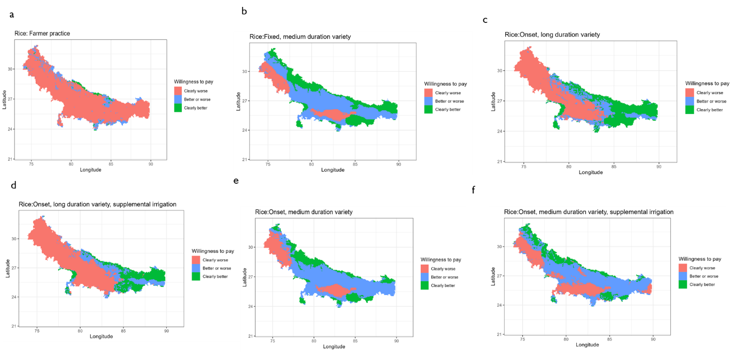

Wheat

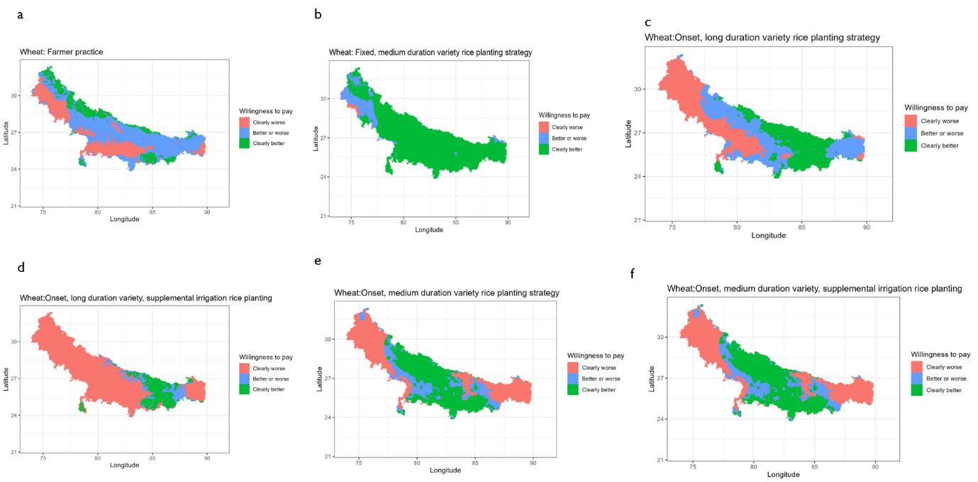

Partial profit

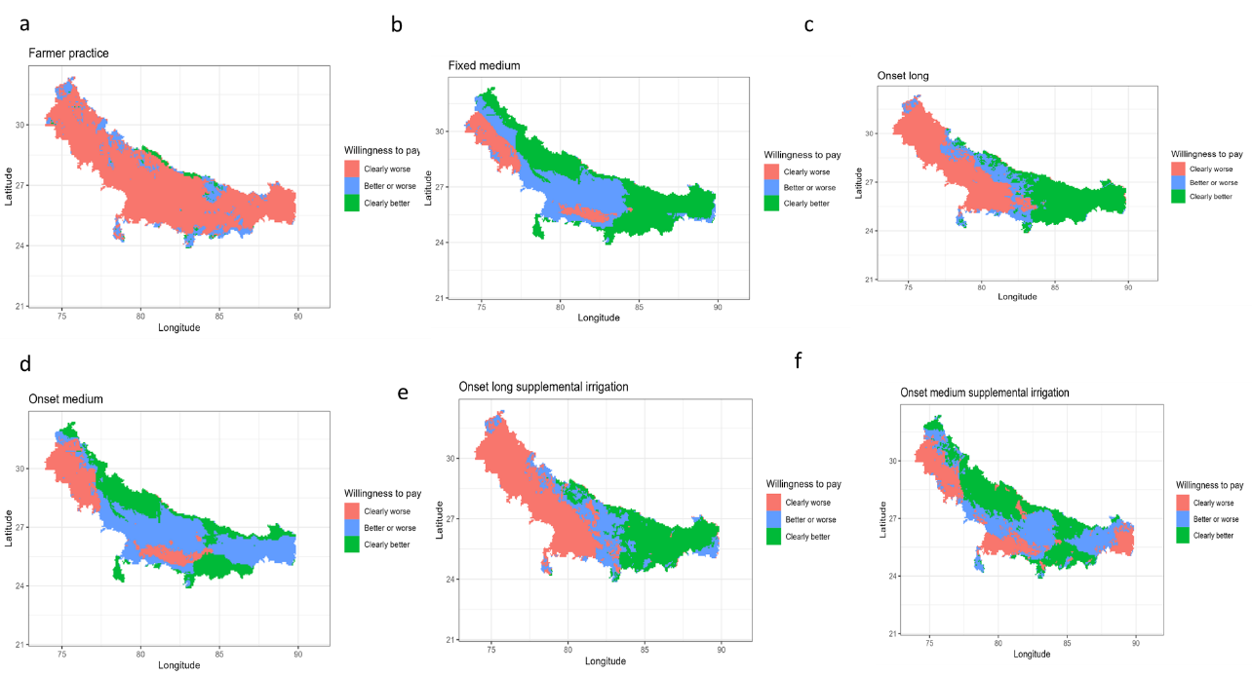

Table: Descriptive statistics table (partial profit)

|  |  |  |  |  |  |  |
| --- | --- | --- | --- | --- | --- | --- |
| Statistics | Rice_Wheat_farmerpractice | Rice_Wheat_medium_long | Rice_Wheat_onset_long | Rice_Wheat_onset_long_suppl | Rice_Wheat_onset_medium | Rice_Wheat_onset_medium_suppl |
| WeightedMean_UB | -15.31 | 40.40 | 12.30 | 7.84 | 23.80 | 25.40 |
| WeightedSD_UB | 22.82 | 28.98 | 42.88 | 46.27 | 31.34 | 34.62 |
| Min_UB | -97.77 | -25.01 | -80.65 | -95.69 | -62.89 | -82.90 |
| Percentile10_UB | -36.40 | -10.73 | -42.52 | -49.44 | -21.58 | -17.54 |
| Percentile25_UB | -26.88 | 24.88 | -16.26 | -27.25 | 7.19 | -1.91 |
| Median_UB | -18.74 | 47.15 | 2.00 | 1.43 | 24.04 | 23.22 |
| Percentile75_UB | -8.09 | 62.14 | 48.44 | 41.74 | 48.21 | 52.55 |
| Percentile90_UB | 6.10 | 72.21 | 77.33 | 79.22 | 63.93 | 74.15 |
| Max_UB | 99.85 | 96.57 | 103.13 | 112.42 | 137.49 | 129.42 |
| WeightedMean_LB | -50.40 | 3.51 | -16.12 | -24.19 | -8.78 | -5.70 |
| WeightedSD_LB | 26.63 | 25.83 | 44.08 | 47.57 | 28.33 | 32.81 |
| Min_LB | -126.29 | -54.20 | -115.70 | -112.73 | -103.66 | -118.82 |
| Percentile10_LB | -79.57 | -23.43 | -73.37 | -82.82 | -38.10 | -47.72 |
| Percentile25_LB | -66.27 | -16.27 | -54.83 | -66.11 | -23.19 | -23.23 |
| Median_LB | -52.75 | -0.94 | -13.87 | -28.33 | -12.87 | -6.43 |
| Percentile75_LB | -35.94 | 20.98 | 16.24 | 13.97 | 6.85 | 12.31 |
| Percentile90_LB | -21.19 | 41.44 | 44.49 | 43.67 | 29.05 | 36.92 |
| Max_LB | 89.66 | 76.40 | 90.44 | 97.08 | 120.33 | 99.99 |
| PropLandinGreen | 0.02 | 0.49 | 0.37 | 0.31 | 0.32 | 0.38 |
| PropLandinYellow | 0.13 | 0.37 | 0.18 | 0.21 | 0.48 | 0.35 |
| PropLandinRed | 0.85 | 0.14 | 0.45 | 0.48 | 0.21 | 0.27 |
| NumberofCells | 17420.00 | 17420.00 | 17420.00 | 17420.00 | 17420.00 | 17420.00 |